“Letter From M.O.M.”
The Bi-Monthly newsletter of Moving On Ministry

WWW.MovingOnMinistry.com
www.PrisonMinistry.net/movingon
Volume 73 – July./Aug. 2012 (Published since Oct. 2003)

“I Can Only Imagine”

As you receive this volume of Letter From M.O.M., we are continuing with more of the testimonies of “How God Changes Lives” as well as some more of our own written articles. We can truly say that the “high” that many of our inmates have been trying to get through the wrong methods, is being surpassed by those putting God in control of their lives.

Watch our website www.MovingOnMinistry.com

We are also affiliated with International Prison Fellowship
www.PrisonMinistry.net/movingon

Fellowship

Our mailing list has cleared over 560. The time required for designing the newsletters, printing, folding and stuffing the newsletters, applying postage and printing the envelopes has become great. We get behind on letter replies, and may occasionally miss one. Please write back if we do not answer, and write clearly so we can get the information correct. We would like to know of the impact we are having and also cherish letters from inmates or relatives to the churches to let us know how we are doing.

Intentions & Wishes

The intentions of this newsletter are to allow an understanding of jail & prison ministries. It is our intentions to get input from those incarcerated as well as those “free” to visit. Life experiences of the faith and fellowship from those locked up in the facilities are always desired to let others know of the value of “visitation”. I am certain that each of us have many stories of the miracles God has done in our lives.
Our wishes are that we would have a list of supportive churches that individuals might look forward to attending, once released.
A list of services, such as housing, employment and counseling services, as well as some individuals available for friendly fellowship are also much needed items (Resource List).
God’s Word says if a man stumbles, how can he continue lest there be another to help him up. Ecc. 4:10 “For if they fall, the one will lift up his fellow: but woe to him [that is] alone when he falleth; for [he hath] not another to help him up.” Proverbs 24:17 “Rejoice not when thy enemy falleth, and let not thy heart be glad when he stumbleth:” John 11:10 “But if a man walketh in the night, he stumbleth, because there is no light in him.”
Please help us with input for this newsletter as we strive to serve God. We appreciate any articles or input.

Addresses to contact our Ministry Volunteers
Moving On Ministry
Chaplain Bob & Linda
P.O. Box 6667

Visalia, CA. 93290

Moving On Ministry
Spanish Ministry
P.O. Box 6667

Visalia, CA. 93290

Recovering from Kidney failure
Andrea Shannon
8405 Jalima Ave
Norfolk, VA 23518

Sister Aleisha (Alice) C.
c/o M.O.M. (Women Only)
P.O. Box 6667
Visalia, CA 93290

Discover Bible School
Attn, Robert
P.O. Box 7175
Visalia, CA 93290

Iglesia Puerta de Salvacion
202 Lafayette Ave.
Lindsay, CA 93247

Missing M.O.M. ?
We must constantly remind individuals that we need to be notified of changes of address or facilities. If we get returned mail (about 20 each month), we remove that individual from the files. If you have, or you are going to be moved, please drop us a note to keep your file active. We get mail returned for bad ID #’s, no cell #, and no bed #.

*********************************
Letters that Express it All

We like to post real life situations, because God works in real lives and He is the one that gives “Eternal Life.”

*********************************
Readily Available Printouts

For those of you that communicate with individuals that have computer access, we have added quite a bit to our web site. The “Resource List” (28 pages), the “Pen Pal Friends” (12 pages), ALL past newsletters (“Letter From M.O.M.”), inmate lookup links, and artwork are available to be viewed or downloaded. www.MovingOnMinistry.com
Ask for a copy of our 28 page
“Resource List”
or our 12 page compiled
“Pen Pal List”
Postage is always appreciated but never required for brochures.
$.45 for Pen pals and
$.65 for Resources
$.45 for Newsletter
(Donations Welcome)

*********************************

Sharing Your Testimony
There are 4 parts to an individual’s testimony;
- What my life was like before I met Jesus.
- How I realized I needed Jesus.
- How I committed my life to Jesus.
- The difference Jesus has made in my life.
The importance is not what you have done, but what God is doing.
- Your testimony
- Your life lessons
- Your godly passions
- The Good News
I would like to add that we have shared many wonderful testimonies. Many individuals are afraid to share their testimony because they are not sure what to write or feel inadequate in their writing ability. I think all will agree, that the testimonies that move people are not the ones written from great minds, but are actually the ones written from a great heart.
God’s Word says in Jeremiah 17:9 that “the heart is deceitful above all things, and desperately wicked: who can know it?” When the heart is changed by Christ it becomes the center of where God works from in our life.

MY TESTIMONY
I’ve studied and practiced witch craft, sorcery for 26 years. I’ve gotten my degree in the occult and had a Covent of 93 people, cast spells, called demons up, dug up graves for the dirt, nails, bones, wood, different bugs and worms that were in and around the graves. I’ve called in the 4 watch towers and other gods and goddesses, sacrificed animals, drank blood, drugs alcohol, orgies, candle burnings of all types, spiritual journeys, out of body experiences, read cards and bones, used different incenses and crystals and caused harm to individuals, both physically and spiritually.
God gives everyone a choice to do as they please. It doesn’t mean He’s not watching. I should have died a hundred times over. I’ve experienced things a normal person would never dream of. I’ve taken a hard road my mom told me. She said in a letter once, is all her children would have done and experienced just half the things I have done, she’d have had to bury half of them. But they were not as stupid as I was. I went to hell and back to teach others what NOT to experience. Would I do it all over again……..HELL NO! There is a lesson to all parts of life; I just chose a deadly one. But God kept me alive to teach others that God’s way of life, is the BEST!
My passion for God is to be the best I can for God and His army, to teacher others of the path of God, to explain where I’ve come from and to teach how wrong my part was. My passion is to try and prevent others from going there. I want to be there for people, to teach my children, my family and my grand-children and to live out God’s best life for me. I try to walk daily as Galatians 5:16-18 teaches and my rewards are verses 22-25.
The good news is I’m saved and delivered by the hands and power of the trinity, God the Father, Jesus and the Holy Spirit.
By Lawrence Staler
************************************************************************
U-Turn Is Highly Recommended
A book I once read told me that it takes intelligence to conceive of an idea, courage inside of me to try that new idea and persistence to make it work. That was a true statement. I’d like to share a few of my ideas with you. I have discovered that what I achieve in my life is entirely up to me and that what anyone else wanted wasn’t going to make much difference. What anyone else would or would not give me wasn’t going to make much difference either. The only thing that really mattered was what I did for myself and what I gave myself through time and effort if I wanted a better life.
I’ve experienced being miserable, at time while being away from my loved ones, but I’ve also learned that being miserable is a habit; being happy is also a habit and the choice is mine. This is one of the most valuable habits you can cultivate. Change what you want to change. Accept what you can’t hope to change. Persevere on being happy no matter what, once you rid yourself of negative feelings trying to control your new life. Misery, as I understand it, loves company and losers love losers. When you are down and out, you don’t need sympathy, you need success. You’ll attract what you are in both people and events. Happiness loves company too, and winners love winners.
Always be on guard against indecision as it’s our foe, one of your greatest destroyers. It drives people crazy and depletes most people’s energy. Insecurity causes procrastination and that in itself leads to indecision. Procrastination is viewed as the art of living in your yesterdays, avoiding living in your today and ruining all of your tomorrows. You have come to your right senses and take of number one or you’ll wind up taking care of no one.
Many of you are familiar with this world famous quotation by Reinhold Niebuhr:
“Give me the serenity to accept what cannot be changed, courage to change what should be changed and the wisdom to distinguish the one from the other.” As you ask for these three gifts, also ask for boldness to quickly withdraw from losing situations. Her is where you need to take a firm stance against failure with these words. “I never see failure as failure, but only as a learning experience that I need to change course in my direction, for this is the game I must play to win.” I must do the most productive thing possible at every given moment. If you make that a habit, you’ll start molding your future, you’ll start making progress towards your goals and you’ll feel the special joy that comes only from being in control of your life.
Say to yourself, with conviction: “I am not judged by the number of times I fail but by the number of times I succeed. The number of times I succeed is in direct proportion to the number of times I can fail and keep on trying.” This is the spirit and blood of a champion. You need to feed yourself with positive words and thoughts each day.
You need to plan for your future instead of worrying about it. If you don’t want to plan for your success and happiness, what right do you have to worry about non-success and unhappiness? If you’re not planning where you want to be, what reason or excuse do you have for worrying about being nowhere? Study and learn how you want to have your life evolve and plan how you’ll make it happen. If you really want something, then that “want” can be your fire that will make a difference in your life. You’ll work hard to satisfy that “want.” You’ll even sacrifice pleasure for it. Put what you think you want on paper. You can consider that a blueprint for your life progress. Look at your written goals and commit to them. Every goal has a price and make sure you are willing to pay the price for it and if indeed you are, then you will succeed in making your goal. Your first step is to commit to your goal in writing.
Begin with short term goals. If it’s not in writing, it’s not a goal, it’s simply a wish and even smoke has more substance than that. Wouldn’t you agree? Review your goals daily. Set present, short, medium and long term goals. A start and an end date. What must you do to make it work? You’ll want accountability of your progress. Who is working with you on your goals? You’ll have a lot of work to keep yourself busy and no more time for feeling miserable. Prepare how you’ll burn or bury your past. Don’t go digging it up again and you’ll be fine. With your progress will come prosperity, joy and reward (not of earthly treasure, but heavenly rewards). Translate your vague wishes into concrete plans. If your goals are attainable, then so much frustration will be avoided. Your progress will be positive. Set goals quickly to get started and then adjust them along the way. You can set 90 day goals, then one year goals and then 5 and even 10 year goals. You are the creator of your goals, working on your wants and desires.
It is good to set goals for many areas of your life; physical, spiritual, emotional and family.
As I close this writing, I ask you to consider Proverbs 13:20 & 21 which teaches, “he who walks with the wise, grows wise; but the companion of fools suffers harm. Misfortune pursues the sinner, but prosperity is the reward of the righteous”. Proverbs 21:16 tells us “a man who strays from the path of understanding comes to rest in the company of the dead”. Proverbs 24:6 tells us “for waging war you need guidance and for victory many advisors.”
May the grace of our Lord help you on your decisions and in helping you to make a safe U-Turn.
By Raul Aguilar
************************************************************************
NOTES:

Doing the birthday cards every month are Carol Ann, her family and Darryl Richardson. We get lots of complements on the personalization of the cards and we try to forward the complements to Carol Ann for sharing with her friends and family.

************************************************************************

Mark David Chapman sent a great suggestion of having a column of “Quotes from Cons” and we would like to add these to the newsletter. Please send yours to us

(1) I’m a Realist (and believe me, Jesus is Real)

(2) Join AARP (American Association of Redeemed Prisoners)

************************************************************************

************************************************************************
New Transportation

We mentioned briefly in the last newsletter (Volume 72) that we got a new vehicle for Linda, and to do the long distance travel we do. The Jeep that Bob had previously bought for Linda’s Birthday in 2010 gave us trouble on the trip to Tucson, AZ. April 2012 Bob decided to buy Linda a new car; a Hyundai Tucson, bought in Tucson, AZ. Oh well, so much for trying to be debt-free (LOL). Linda actually sat in the Jeep and cried before we traded it in for $500.00 trade-in.

April & May were extremely busy with the end of April trying to get into the Federal penitentiaries in Tucson to do chapel services. The facilities were booked up for the week but we were asked to please try again. We are also working on getting into the facilities near Bisbee, AZ. and Sierra Vista, AZ.

May found us dedicated every weekend to a different facility.

May 4-5. put Bob in Avenal State Prison on 6 yard and 4 yard. Linda and Jessica were assigned to both of the Chowchilla women’s prisons.

May 13 was the Sunday Bob, Linda & Carol did chapel services at Corcoran State Prison.

May 20 was chapel services for Bob & Linda at California Men’s Colony East yard in San Luis, CA., where attendance was 177 + men. Service was Spirit filled with one of the highlights being Linda’s 2nd song of “Jesus, Lover of my Soul” where the band and all the men joined in singing with tears of joy.
Now for the Full Travel Story

The original idea of the trip to Tucson Arizona was to do a combination vacation and be able to possibly provide chapel services at the two Federal Penitentiaries in Tucson, AZ. When we expressed our desire to do services at the facilities, the chaplains were surprised we would want to spend our vacation that way. We explained that if we were not in prison, it was not really a vacation. They already had the week booked with services, but asked us to please try again.
We decided to take Linda’s Jeep so we could save on gas. Bob’s 10 mpg 4X4 Dodge vs. Linda’s 24 mpg 2WD Jeep. Missing a turn from the CA 57 to the CA Highway 210, we next found ourselves headed to San Diego and then would find ourselves going thru San Diego and taking the CA Highway 8 back to Arizona.
As we traveled the trip over, the Jeep would cutout and die, like electronic ignition or a fuel pump. As we got within 150 miles of our destination, the check engine light came on and Bob noticed the battery voltage showed about 11 volts. We made it to a station that had batteries and paid $119.83 for a battery (trade-in with the Jeep). The Jeep continued to run to the motel but never did get above the 11 volts – figuring the alternator was bad now. We got to the motel that Bob’s daughter rented for Saturday night and checked in. We asked the hotel to allow us to go with them to pickup Bob’s daughter when her flight came in.
The hotel manager told us that she used a contracted shuttle agency but later informed us that she had a shuttle driver for the hotel van and we could go. We got to the airport (1.8 miles away) and the driver pulled up to the private vehicle pickup. A security officer walked up and asked the driver what he was doing there? The driver answered he was picking up my daughter. The officer explained that he should be at the commercial pickup and not the private. The officer then detained the individual (with us in the van) and proceeded to write up the individual. It was at this point that it was found out the driver had his license suspended and revoked. He was arrested and then let go with a citation. Bob went and found his daughter, and the police department drove the hotel manager to the airport to drive the van back to the motel.
We spent Saturday night trying to relax and worrying (I know it is a sin to worry) about what we were going to do for a car. Bob’s daughter got a rental car for two days. We checked out of the hotel near the airport and drove the rental car to the resort we were to stay at Sunday thru Friday. After we checked in Sunday morning, we went to the car lots to see what was available, knowing the dealers kind of had us at their mercy. All the lots were closed on Sunday, which gave us the freedom to look around. We narrowed it down to 3 used and 2 new models we liked.
Monday morning we went to the dealer and got a sales person to help us pick a model and set up financing. What seemed like a long time later, we were put in the seat of a new Hyundai Tucson with so many features, Bob will have to go back to major in engineering to work them all. The vehicle actually has nine (9) computers onboard to keep everything working. You can actually talk to the radio and make a cell phone call.


Starr Pass Resort and golf course in Tucson Arizona.


Casitas at resort.


Casitas we stayed in

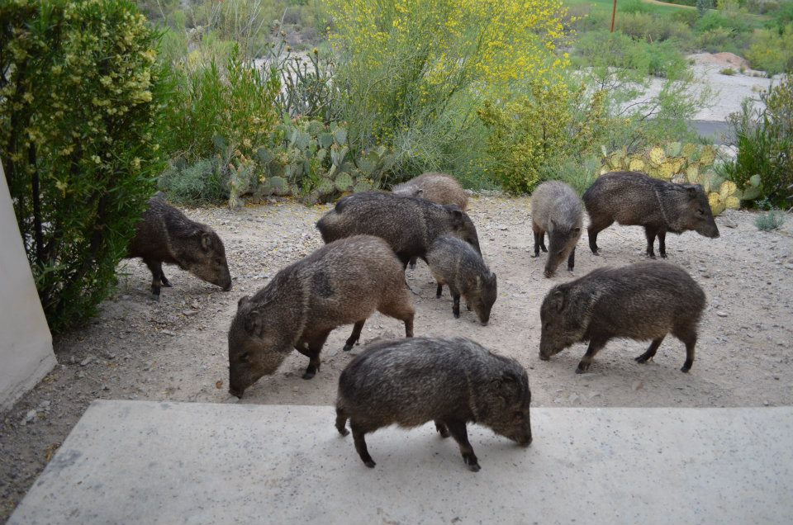
Feed one and the whole family comes (Javelina) to visit outside your patio door.

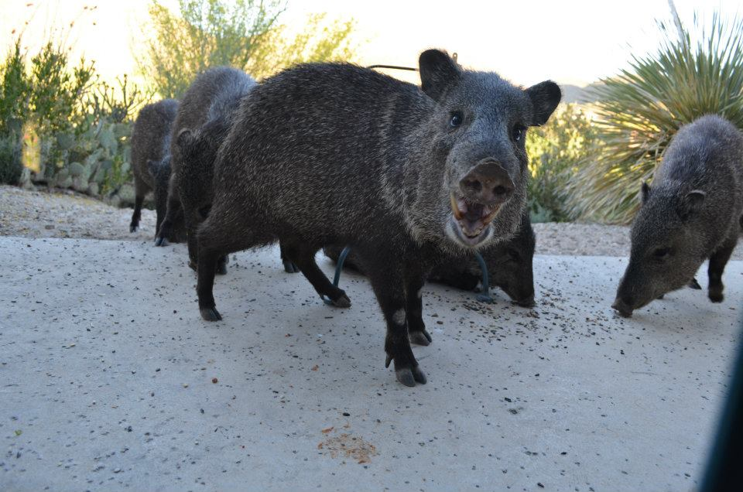
Showing Fierce


Showing Love
************************************************************************
He First Loved Me

LOST IN SIN One Man's Story - by Phillip DeWitt Burdick

"For the wages of sin is death" (Romans 6:23).

San Quentin state prison is a terrible place to stay for a night, much less years. But, after five years in Soledad on a life sentence for murder, it was either there or Folsom. You see, I was one of those hardened criminals with a long, long record. The California Department of Corrections wanted to make sure I never escaped or hurt anyone again, other than, other psychopaths who just couldn't be trusted in society, who no one but their mother could love anyway!
I was just trying to survive one day at a time, because the convict code was "anything and everything goes." Men kill for less than the price of a pack of smokes ... reduced to no more than animals in a zoo. I was dead, though even that would have been comforting, relieving me from my real anguish within of constant fear twisted in hate, guilt and lies. Death was almost peaceful sounding!

STARING AT DEATH

It was April, after many days of shooting Methadrine (intravenously injecting), smoking pot and drinking pruno (prison made wine) that I found myself facing death many times in my life, but never knew, smelled, or felt death's eternal stench like this. Fear gripped my soul!
The knife at my throat was held by a man with two life sentences running wild, or in other words, he needed more than a miracle to ever see freedom again. He was a hardened, cold-blooded killer who made a reputation off of just that. His eyes bled with anger and his brow was wet with moisture as he tightened his grip to slit my juglar vein and watch me die. No! He taunted me first, knowing I was powerless and frightened. He was drunk, and crazed on drugs as well. We were alone in a cold, lonely, darkened cell. I accepted death at that moment, my life passing before my mind's eyes at the speed of light.

HEADIN' FOR TROUBLE

"For all have sinned and fallen short of the glory of God" (Romans 3:23).
At nine years of age, I was arrested for bullying a kid into stealing booze from his father. He told! I started a life of crime that really wasn't life at all.
I was born in 1951 and raised in Monterey, California with two sisters and an older brother who thought I was cool only when I'd get arrested and hold my mud (not tell anyone else!). I wanted so much to fit in with my older brother and friends. Fourteen trips to juvenile hall later, I found myself at a boy's ranch in Salinas, California for a year. I had already picked up street ways, bad habits and a dirty mouth; all of which were very cool I thought.
After a year in juvenile hall, I got out and "my cool" figured out that sex, drugs and rock 'n roll was the answer to life's big questions. With the help of my father, I had already been playing the drums for a few years. This to me was the plan -- to be a rock 'n roll star with all the drugs, sex and power that comes with it!
It wasn't long before the "drugs" part of my plan landed me in California Prison for Boys at Stockton for a two year stretch for assault with a deadly weapon!

A NEW START

More drugs and night clubs followed my release, and although when I got out I was married and had a daughter, nothing inside me changed. After another long stretch of shooting dope (any kind, by now I wasn't choosy), I left my wife and a job as a broiler man at a large casino in South Lake Tahoe. I sold my drums and went back home long enough to kiss my daughter and hit a pharmacy for $25,000 worth of drugs and was gone again.

ON THE RUN

I was already on the run for several crimes and just didn't care anymore. The man I killed was just someone who was in a bar that I happened to be at when my money and drugs ran out months later. I beat him to death with a hammer and left him in the woods for $75 and his car! No, I can honestly say I didn't take him out in the woods to kill him, but that does nothing for the responsibility I feel in killing him, nor does it matter that I was out of my mind on drugs. No one forced me to do anything, especially swing the hammer 23 times!
All this was coming to mind, all my sins, all the lies, all the perversion and sickness! But still, after I was convicted for murder and sent to prison for life, I did not repent and turn from my wicked ways. They only became confined to a smaller area with less freedom. Still, I managed to get enough drugs and make my own wine to kill the guilt and fear, or at least suppress it. I thought there was no hope in my future.

THE AWAKENING

So here I was after 30 years of life, 15 of which were incarcerated in California institutions [off and on since nine years of age] ready for death. Suddenly, all the emotions of my life were compressed in fear of certain death and my soul cried to a God I had never known, a God I ran from, a God I had always refused to believe in. "The very God who loved me!"
"...I have set before you life and death, blessing and cursing: therefore, choose life, that both thou and thy seed may Live... " (Deuteronomy 30:19).
"Oh God!", I cried, "Don't let me die like this. I'm so afraid! Save me from the hand of my enemy!"
"Call unto me, and I will answer thee, and show thee great and mighty things, which thou knoweth not" (Jeremiah 33:3).
"In my distress I called upon the Lord, and cried unto my God: He heard my voice out of His temple, and my cry came before Him, even into His ears" (Psalms 18:6).
It was as if I left my body and my assassin was below me still with the knife held up against my throat, as I was watching myself talk very calmly to him. I watched as he took the knife from my throat and handed it to me as I heard myself calmly say, "Give it to me my son."
Suddenly, I was back in my body and all fear was gone. I gave him the knife back and walked past him into the night. Confused and not really knowing exactly what had happened, I went to my cell and slept. A life changing miracle had happened!
"And the times of this ignorance God winked at; but now commandeth all men everywhere to repent" (Acts 17:30).

A NEW DAY

The next morning was a new day in my life. Though I tried to get high and carry on in sin as before, nothing would work like before to kill the pain of my troubled soul.
Soon, I was transferred to California Men's Colony in San Luis Obispo, and my new life had begun as I became more and more aware of a loving Savior and the calling on my life.
It wasn't long before I gave my life to Jesus Christ and was baptized at the Dynamic Prison Church by brother Charles, the minister. "I was a new creation in Christ - a brand new man!"
"Oh God!" I cried. "Save me?"
"Therefore if any man be in Christ, he is a new creature: old things are passed away; behold, all things are become new" (2 Corinthians 5:17).
"Happy is he that has the God of Jacob for his help, whose hope is in the Lord his God: Which executeth judgment for the oppressed... The Lord looseth the prisoner" (Psalm 146:5,7).
"I the Lord have called thee in righteousness, and will hold thine hand, and will keep thee, and give thee for a covenant of the people, for a light of the Gentiles; To open the blind eyes, to bring out the prisoners from the prison, and them that sit in darkness out of the prison house" (Isaiah 42:6,7).

GOD CALLS THE FOOLISH THINGS

As I sit in my cell right now, I can't believe life is so good, so fulfilling with Christ in my heart. It hasn't been all rosy and joyful the last many years because of a lot of tearing down of old beliefs and building on God's Word has had to take place.
Although, I still play drums only now for God's glory in praise and worship services at the prison chapel. My Heavenly Father delivered me from drugs, cigarettes and sins of all kinds. Though I'm still in prison and doing a life sentence with no date for release after two decades for the murder I committed, I am freer than I've every been in my life. I'm no longer in bondage of any kind! Praise God, I'm falling more in love with our Lord everyday.
"And you shall know the truth, and the truth shall make you free--- If the Son therefore shall make you free, you shall be free indeed" (John 8:32,36).
I'm truly blessed with a calling and the gifts of the Spirit. I've been a deacon in the prison chapel, the director of the outreach department, taught and witnessed in this capacity, counseled men as a moderator of our Yokefellow program [Christian group counseling, Matthew 11:28-33, Philippians 4:3], as well as ministering in many other capacities over the years. I'm growing in the grace and knowledge of our Lord Jesus Christ.
Today, I have many brothers and sisters who care and show me so much love. It's a large family! Many of my brothers, with life sentences as well, have gone off to other prison mission fields, others have been released. Through prayer and reading God's Word daily, I have a prosperous and successful life.
"For this book of the law shall not depart out of thy mouth; but thou shall meditate therein day and night, that thou mayest observe to do according to all that is written therein: for then thou shalt make thy way prosperous, and then thou shalt have good success" (Joshua 1:8).
I've found that "by grace through faith we are saved" as we trust in Jesus and the sound guidance of the Holy Spirit.
"For by grace are you saved through faith; and that not of yourselves; it is the gift of God; not of works, lest any man should boast" (Ephesians 2:8,9).
In all this there is a peace and the blessed assurance of an eternity with our Lord in Heaven. Only God can change a heart as hard and a mind as scrambled as mine was. If it was left up to me, I would be dead, but God is faithful to save the sinner who cries out to Him!
"No man can come to me, except the Father which hath sent me draw him..." (John 6:44).
"For whosoever shall call upon the name of the Lord shall be saved" (Romans 10:13).
"For God sent not His Son into the world to condemn the world, but that the world through Him might be saved" (John 3:17).

IS GOD CALLING YOU?

Jesus is the Son of God and He took our place. He died on the cross and shed His blood for our sins so that we can have abundant life in Him and eternal life as well. God loves us and wants us to live with Him forever! Jesus promises us in John 6:37, and him that cometh to me I will in no wise cast out."
If you would like to receive Jesus Christ into your heart as your personal Lord and Savior, pray this prayer now. But remember, it's not the prayer that saves you, but the work of Christ at Calvary's cross.
"Jesus, I believe that you are God's Son and that you died on the cross for my sins, and were raised from the dead so that I can have eternal life. Come into my heart and forgive my sins; I receive you right now as my Lord and Savior. I give my life completely to you.
Heavenly Father, lead and guide me in your perfect will and plan for my life. Thank you for saving me and making me your child and for giving me eternal life through your Son. I am now saved and belong to you. In Jesus' Name, Amen."
Thank God every day for saving you and making you His very own child. Don't go by your "feelings", go by what His Word says!

TO GROW AS A CHRISTIAN

1. Read your Bible every day to get to know Jesus better. He speaks to our heart through His Word. His Word is His Will for our life; He has chosen to reveal Himself to us through His Word. Begin reading with the Gospel of John.

2. Talk with the Lord in prayer every day. Close fellowship with Him is so important. Pray to the Father in Jesus' Name, John 16:23. Simply be open and honest with Him as you would to your best friend -- that's exactly who He is! He loves you and understands you and is interested and concerned about every area of your life.

3. Tell others about Jesus -- witness! Share with them what He's done for you and how they can also have eternal life by accepting Jesus as their Savior. You'll grow stronger as you do! Proverbs 11:30, "...he that winneth souls is wise. "

4. Be baptized; worship, fellowship and serve with other Christians in a church where Christ is preached.

5. Write Phil and let him know so I can rejoice with you!

PHIL BURDICK B-82439
P.O. Box 8103 Rm. #8226
San Luis Obispo, CA 93409-8103

************************************************************************
Need of Supporting the Ministries

The following email was an example of what is happening to ministries;

Hello Bob;

Yes, unfortunately it (Paper Sunshine Pen Pal ministry) is (closed). For the three years we were in existence, we were unable to cover our expenses. It was very difficult to make the decision, but it had to be done. I appreciate your concern, and may the Lord bless you and your ministry in every way.

Pastor Dave Fletcher

PLEASE write relatives, friends and churches to support the ministries that provide so much to each of you.

************************************************************************

************************************************************************

God’s Word…His Brand

God’s Word is the wholesome fruit, (1 Peter 1:25 – 2.3)
From the tree of life-giving breath, (Revelation 2:7)
Not the false rotting fruit, (Matthew 7:15 – 20)
That falls from evil’s tree of death. (Romans 7:5)

With God in our life, (Micah 6:8)
And Jesus by the hand, (Colossians 2: 6-7)
Love tying us together, (Romans 8:28)
United we will stand. (Psalms 133:1)

Beware of the temptations, (Mark 14: 37-38)
From evil things of the dark, (Proverbs 1: 8-19)
They will surely devour you, (Proverbs 30:14)
Like a vicious feeding shark. (Psalms 10: 8-10)

The devil tries to shroud us in darkness, (1 John 2:11)
Sin hiding us from God’s light, (Romans 3:23)
Deceiving us about God’s truth, (Hebrews 3: 12-13)
We were never out of God’s sight. (Hebrews 4:13)

Straddling that tenuous fence, (Matthew 6:24)
Is a dangerous balance act, (Revelations 3:16)
Flying that band of middle ground, (Matthew 7: 13-14)
Has a price it will exact. (Romans 6:23)

Like castaways lost at sea, (Matthew 18:11)
There is a signal in the night, (Psalms 119:105)
For those who live in God’s will, (1 John 1:7)
In this vast ocean filled with plight. (John 16:33)

If to His Word we will listen, (John 5:24)
As we contemplate His plan so grand, (1 Corinthians 2:9)
A helper He will send to us, (John 14: 16-26)
If in our heart we wear His Brand. (Hebrews 10:16)
By Jeffrey Price

************************************************************************

THE HOLE

Stranded and lonely with nowhere to go,
Quickly losing my mind and damn near my soul.
This is so dark and it oh, so, so cold,
with no one around and no one to hold.
Can’t make a phone call, ain’t received mail in days,
Only thing left to do is drop to my knees and pray.
Dear Lord, I need an answer, can you please give me a sign,
How does this pain hurt so deep to a person of my kind?
I know I’m far from perfect and repeatedly broke the law,
Am I playing a game of win, lose or draw?
The draw I’ve had and lost so many times and more,
still searching for that win to even up the score.
The pain hurts so deep, you wouldn’t understand,
the feelings deep inside of that woman or man.
Children are always first in your sights,
To keep from dying you continue to fight.
Nightmares awaken me deep in the night,
Tossing and turning in cold sweats and fright.
Lord, I promise to play my part,
Can you please allow me just one last start.
I give you my word and promise to change,
Stay away from the streets and get the hell out of the game.
Devil got the best of me, he’s broken me down,
The tears keep falling not making one sound.
The pain indescribable, you don’t want to know,
The way it really feels to be stuck in the hole.
By Brandi Balmer

************************************************************************

THE ROBE

Last night I dreamed I saw Jesus in heaven, with a host of angels on high,
With a robe of white around Him and His Father standing nearby.

Yes, I saw Jesus in heaven…….oh, how happy He seemed to be,
But I heard the angels saying that Jesus was waiting for me.

I saw all the angels around Him, their robes as white as could be,
But there was one robe missing, the one Jesus was holding for me.

I saw all my loved ones around Him, their robes were beautiful to see,
And Jesus was there holding the robe, that He saved for me.

I saw all the mansions in heaven, I saw the one Jesus built for me,
To be with Him in glory, in the robe He saved just for me.

When I woke there was a change in my life and that change was plain to see,
For I knew someday I would be in that mansion, in the robe Jesus was saving for me.
By Larry Staler

Toni’s Testimony

I was born to a mother of 16 years old. My biological father abused her something terrible. He shot dope, robbed people, sexually assaulted women and molested me for months when I was age 9. My mother remarried on my 10th birthday to a wonderful man from a Christian family. This was a sharp contrast from the maternal grandparents I have, which for years were bootleggers. My grandfather is a member of the KKK. I was a straight A student in school despite everything until 7th grade, when then the neglect and mental abuse of mama and the recent sexual abuse of my biological dad caught up with me. I had met Jesus at summer camp at age 10, but I did not know him until years later. I ran away from home at 12 and also became sexually active at the same time. My step-dad, whom I loved very much, spent most of his time with me, teaching me how to fish, then he played in a band on the weekends. My mama bartended during the day, but even in her off time she never spent any time with me. She never helped with homework, never even got me up for school after the 3rd grade. My parents, mommom & poppop were the wife and minister of the church that sponsored my summer camp, but I didn’t get to spend much time with them. I ran away at 14 again, caught a STD and my pregnant mother petitioned against me at the juvenile court and I was sent off to maximum security juvenile detention for 2 months and then to Mt. Meigs boot camp. It was the real thing, like what soldiers go through. Horrible!
I got out and did well for a while, until I was 16 and my pregnant mom, step-dad, little sister and I up and moved to the neighboring county and bought a “honky tonk.” I was used to going to an all- white school and now was thrown into one of all races. I was traumatized. Black boys terrorized me every day, trying to sexually touch me and I came home every day crying. So I quit school and got myself a D.U.I. It was probation for me again, court ordered counseling for me and mom, which was even worse. I was put on probation for the D.U.I. and it got revoked, so I was sent off again to the same place, then to another boot camp, where I turned 18.
Three months after getting out I got pregnant with my daughter, Missie. When I couldn’t fight off peer pressure from my biological father, who was now out of prison after a 10 year stay, I tried crystal meth. It was all downhill from there. Many different physically abusive relationships, 2 more STDs, all of them curable (thank God) and 3 abortions behind me, I finally got over being prejudice and had me a mixed baby boy, Cody. His dad was from Honduras. I stayed in and out of jail for drug paraphernalia and fines owed on tickets, then finally the big one for trafficking. Thanks God I’d already got rid of my gun. I gave my son Cody to my close friend who couldn’t have children and even gave him her and her husband’s last name. I love him very much but I couldn’t take care of him. DHR had already taken my daughter for me failing a drug test for pot and meth.
I got out long enough to have another baby boy, Hayden. Then in and out again after he was 1 year old, so his dad and grandpa got him. Then I stole checks from mom and got a forgery charge, plus got pregnant with twin boys, Cameron and Noah. I only came home with Noah because Cameron was med-flight out to a distant hospital with a heart defect. He was 5 days old when I got a room at Ronald McDonald House. He was 7 days old when he had open heart surgery. I was alone because my friend who had Cody also had to take care of Noah while I was with Cameron. Of course I knew I would eventually go to prison, so I gave Cameron and Noah the same last name as Cody, preparing to give them to my friend also when the time came. All 5 kids have different dads. When I brought Cameron home at 4 weeks, I had Hayden and the twins and only was seeing Missie when I started church. Faithfully for a year I went to worship my Lord for He’d brought me through. Then I was jailed for a year and then off and on until I got mixed up with a man who killed another man in 2009.
Now I sit in prison, 1 year now, for revoked probation, with a pending capital murder charge that I’m not guilty of. I’ve had 2 slight nervous breakdowns but I’m holding onto Jesus. I’ve read my Bible from to back, four different versions and have a good support system from the family who has my children. I know I have a job to do for my Lord in prison and when I get out. I will walk out of here on day. They’re talking about a 20 year sentence. I pray for God to reveal to me what He wants me to do. I’m through with drugs for sure. I’m 34 years old now and maybe this testimony will open the eyes of someone going through what I have and still am. I am blessed and lucky to be alive. My children even write me and send pictures. He will restore all things to you too. Just ask. By Toni Collins

************************************************************************
Moving On

When my past came a calling
I said a prayer and wrote a note
By the time you’re done reading this
You’ll know just what I wrote.

My walk with God was being tested
By a dark shadow disguised in light
Its appearance was quite attractive
But there was something not right

Oh, how my pulse did quicken
And my heart more than skipped a beat
With closed eyes I took a deep breath
And shifted in my seat

My thoughts turned heaven bound
As my flesh was put in check
The last time I gave into this
Ended in a big wreck.

My lord was crucified
For times such as this
To save me from my sins
So God’s wrath I would miss.

I wish not to suffer like one Judas
Who’s fate was sealed with a kiss
But rather to follow God
And receive eternal bliss

Yes my past came a calling
But I could not be found
As I approached the throne of grace
With my face to the ground

Glory be to God
I’m moving on, moving on
Jesus washed away my sins
Thank God, I’m moving on,

Drawing by
Leroy Merriex



