“Letter From M.O.M.”

Volume 108

Quarterly newsletter of Moving On Ministry

WWW.MovingOnMinistry.com (Since April 2001)

Volume 108 – Apr May June. 2020 (Published since Oct. 2003)

************************************************************************

“I Can Only Imagine”

As you receive this volume of Letter From M.O.M., we are continuing with more of the testimonies of “How God Changes Lives” as well as some more of our own written articles. We can truly say that the “high” that many of our inmates have been trying to get through the wrong methods, is being surpassed by those putting God in ownership of their lives.

Watch our website www.MovingOnMinistry.com

We are also affiliated with International
Prison Fellowship
www.PrisonMinistry.net/movingon

Fellowship

Sorry that we are getting the newsletters out late. Bob’s typing is slow and the folding of the newsletters is being done by Bob & Linda because of not having the typing done in time for the board meeting. With the crashing of the computer this last year, we are building a new mail list. We got behind on letter replies and Resources Lists, and may occasionally miss one. Please write back if we do not answer, and write clearly so we can get the mailing information correct.

Intentions & Wishes

The intentions of this newsletter are to allow an understanding of jail & prison ministries. It is our intentions to get input from those incarcerated as well as those “free” to visit. Life experiences of the faith and fellowship from those locked up in the facilities are always desired to let others know of the value of “visitation”. I am certain that each of us have many stories of the miracles God has done in our lives.
Our wishes are that we would have a list of supportive churches and programs that individuals might look forward to attending, once released.
A list of services, such as housing, employment and counseling services, as well as some individuals available for friendly fellowship are also much needed items (Resource List).
God’s Word says if a man stumbles, how can he continue lest there be another to help him up. Ecc. 4:10 “For if they fall, the one will lift up his fellow: but woe to him [that is] alone when he falleth; for [he hath] not another to help him up.” Proverbs 24:17 “Rejoice not when thy enemy falleth, and let not thy heart be glad when he stumbleth:” John 11:10 “But if a man walketh in the night, he stumbleth, because there is no light in him.”
Please help us with input for this newsletter as we strive to serve God. We appreciate any articles or input.

Missing M.O.M. ?
We must constantly remind individuals that we need to be notified of changes of address or facilities. If we get returned mail (about 20 each month), we remove that individual from the files. If you have, or you are going to be moved, please drop us a note to keep your file active. We get mail returned for bad ID #’s, no cell #, and no bed #. Make sure that your return address is inside the envelope as well as on the envelope – we get many damaged envelopes that are unreadable.
*********************************
Letters that Express it All
We like to post real life situations, because God works in real lives and He is the one that gives “Eternal Life.”
*********************************

Sharing Your Testimony

*********************************
There are 4 parts to an individual’s testimony;
- What my life was like before I met Jesus.
- How I realized I needed Jesus.
- How I committed my life to Jesus.
- The difference Jesus has made in my life.
The importance is not what you have done, but what God is doing.
- Your testimony Your life lessons
- Your godly passions
- The Good News

For those of you that communicate with individuals that have computer access, we have added quite a bit to our web site. The “Resource List” (56 pages), ALL past newsletters (“Letter From M.O.M.”), inmate lookup links, and artwork are available to be viewed or you may download.
www.MovingOnMinistry.com

I would like to add that we have shared many wonderful testimonies. Many individuals are afraid to share their testimony because they are not sure what to write or feel inadequate in their writing ability. God’s Word says in Jeremiah 17:9 that “the heart is deceitful above all things, and desperately wicked: who can know it?”

*********************************
PLEASE Pray that the churches, friends and relatives of inmates would become supporters of this Jail/Prison ministry.

We have downsized the mailing list according to those responding with profile sheet updates

We have dropped to getting 60 to 100 letters/requests per month. Let those on the outside know of how much good M.O.M. does for inmates.

Because we don’t get paid doesn’t mean its free. We need support for expenses.

Addresses to contact the Ministry Volunteers

Keep Believing Ministries
P.O. Box 257
Elmhurst, IL 60126

Otto & Jennie Ball
c/o Crossroads Ministry
P.O. Box 363
Hyde, PA 16843

LaVoz de La Esperanza
101 W. Cochran St.
Simi Valley, CA 93065

Set Free Prison Ministries
Bible Correspondence Course
P.O. Box 5540
Riverside, CA. 92517-9986

Ministero de Prison
P.O. Box 543
Live Oak, FL 32064

Jesus People Info. Center
4338 Third Avenue
Sacramento, CA 95817

Crossroad Bible Institute
P.O. Box 900
Grand Rapids, MI 49509-0900

Calvary Chapel Prison Ministry
Attn: Carmine Aleprete
P.O. Box 1965
Big Bear Lake, CA 92315

Little Lambs, Inc
John & Eileen Sala
P.O. Box 32
Sebring, FL 33871-0032

The Felony Foundation (TFF)
P.O. Box 190806
Dallas, TX 75212-0806
(Pen-pals)

El Concilio Del Condado
301 So. C St.
Oxnard, CA 93030

Iglesia Puerta de Salvacion
202 Lafayette Ave.
Lindsay, CA 93247

World Challenge
P.O. Box 8930
Pueblo,CO 81008-8930

International Prison Ministry
Bible, Dictionary, Concordance
P.O. Box 1088
Chula Vista, CA 91912-1088

*******************************************************************************************

*******************************************************************************************************

A really nice and encouraging letter from Mr. Douglas
How are you? I pray that both of you, ministry and ministry volunteers are doing well. You have been awesome. I really enjoy seeing the pictures of the cars you built. I’m a car guy and I just love it. Every issue was shared with my friends. WOW!
**********************************************************
I’m writing to give up updates. God has blessed me so much in these last 16 years. Thanks to living for Jesus and the Holy Spirit for keeping me on the straight and narrow path. If there is a “secret” to living for Jesus in prison, it’s this:
1. Give your life totally to Christ – No Reservations!
2. Get baptized ASAP.
3. Pray every day, throughout the day – Be Frivolous!
4. Read your Bible every day – Bible studies are great.
5. Hang around Christian believers who will mentor you.
6. Go to church – one that believes wholly on the Bible.
7. Forgive Freely & accept forgiveness.

This is a winning combination that will never let us down and draw us closer to God. We never “arrive” because we are on a journey that will end only when our Lord tells us, “Well done good & faithful servant.” What an awesome day that will be!
Love you all very much. Keep up the great work you are doing.
Keep the smiles turned to bright. *** Ray Douglass ☺ ☺ ☺ ☺ ☺ God Bless you Ray, from all at M.O.M.

*********************************************************

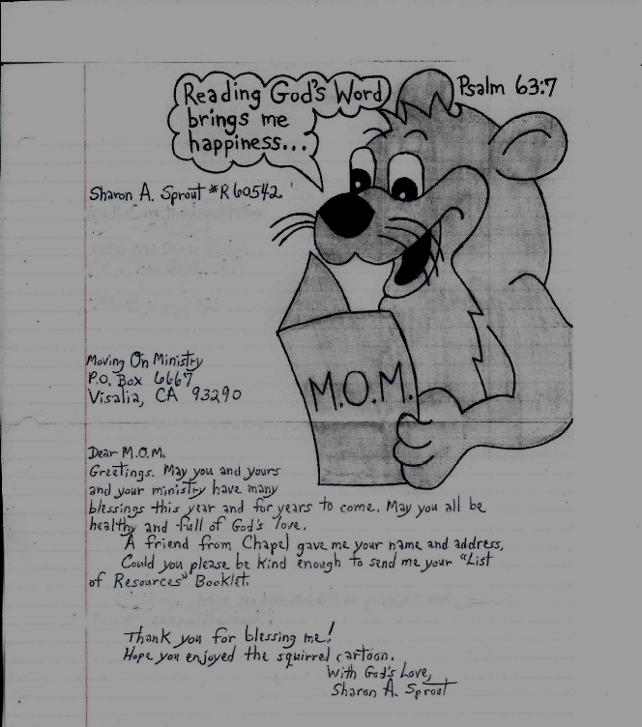

****** Part of Letter from Brother Tim Fletcher who has been such a great encourager to other inmates ******
......God is good! I'm studying like a true soldier. Preparing for Bible College : ) ................. Trying to get a "Christian Living Class up and running. It's been a struggle but nothing but nothing worth having comes easy or without cost.".............. " what started out as a quick look has now turned into the works of a book based on Scripture."......... " We need to get back to the simplicity of the Word of God. Man has corrupted it so much but the inerrant Word of God is still here for us to live by. UNITE, SEARCH OUT THE TRUTH AND LIVE BY IT. SIMPLE!"
( Very encouraging to read this from Tim. God Bless you.)
San Diego Bill Glass Behind the Walls February Event
The Bill Glass BTW event was held on February 22nd at RJ Donovan S.P. and was my 5th BGBTW event. Each Behind the Walls event seems to get better and more powerful every time. There were reports of possible rain for Saturday and all of the event Coordinators and volunteers prayed earnestly the night before at our Ignite and Equip meeting for the rain to not flow around the Donovan State Prison during the event. There were 8 M.O.M. (Moving On Ministry) volunteers, who signed up for this event, plus 2 other M.O.M. volunteers who came along for support.
The devil was trying to stop all of us who were signed up volunteers, from coming in to the facility. There were several hurdles and delays from the time we met at the Prison at 7:00 A.M. until we were able to walk into the Yard, well after 9A.M. While we were standing around waiting to gain entrance into the facility, there were several instances where rain drops began to fall, lightly. Several of us commented that these rain drops were actually God bringing blessings to the facility. Also during this time, we kept getting different reports of problems in one of the yards that we were assigned to go.
So, during our walking into the facility to the first yard, it lightly rained and it had been determined to hold the event in the gym(s). As we were waiting for instructions on setting up the event, a group of us went to the 2nd yard. The rain came down a little harder during this jaunt. As we were trying to set up in this gym, another hurdle occurred and we were led to a different yard that wasn’t in the plan (God has a way of determining where He wants us to be.) This was our 3rd jaunt and the rain came down during our move. Just as we all got into the gym, the rain burst over the Prison. (The rain stopped soon after we were able to set up in this particular gym/yard.)
It should be noted that there was some apparent resistance from the Prison to even allow the Bill Glass volunteers to go through with this event. After much discussion it was determined to stick with it and plow forward. We were split into two groups, initially, but when we finally made our trek into the yards; we all went to one yard. Later, as described above, the 2nd group was led to a yard that was not planned. The beauty of this was that we were welcomed by a big showing of inmates who were not afraid of peer pressure and felt the hand of God. The majority of these inmates were filled with the Holy Spirit, along with Love, Peace and Joy. Many of the inmates had been praying for quite some time, but remained steadfast, reading the Bible, studying the Bible and praying. There is always Hope and by all means, if you start by reading the Bible, God will speak to you. You need to open: your eyes of understanding, your ears to hear His voice, your heart to receive, and your mind to discern the light from the dark. Stay in the Word.
Read James 4:7 NKJV Therefore, submit to God. Resist the devil and he will flee from you. Remember the devil has no dominion over you. Even though you are forced to live in the devil’s playground, does not mean that the devil can influence you. Stay strong and always Praise God for everything, no matter how hard your situation may seem. Study and read the whole book of Job. You think you have it bad, just see what Job went through as a righteous man! There are so many stories in the Old Testament and the New Testament that we can all relate to. We are all sinners. We all need Salvation.
Praise God!!
Pastor Bonnie

**********************************************************

This is from another faithful reader ☺ ☺ ☺ ☺ ☺
Dear M.O.M.
I just wanted to update my info and also thank you for continuing to include me in your mailing list. I really appreciate receiving your newsletter and reading about the stories people share and getting updates on “Bob’s health.” I also appreciate having something to look forward to during mail call. That can be a tough situation for some people who have nothing to look forward to at all, especially during the holidays. So thank you for that and please enjoy the holidays. Take care and may God Bless you all. Luis M.
P.S. I always keep you in my prayers Chaplain Bob.
(Mr. Martinez always keeps in contact with us. .Keep up the “GOD WORK” Luis. We really appreciate these letters and read several at each meeting. The ministry team is also blessed after hearing these encouraging words Linda

F.E.A.R. has two meanings: Forget Everything And Run or
Face Everything And Rise. …………The choice is yours☺
**********************************************************
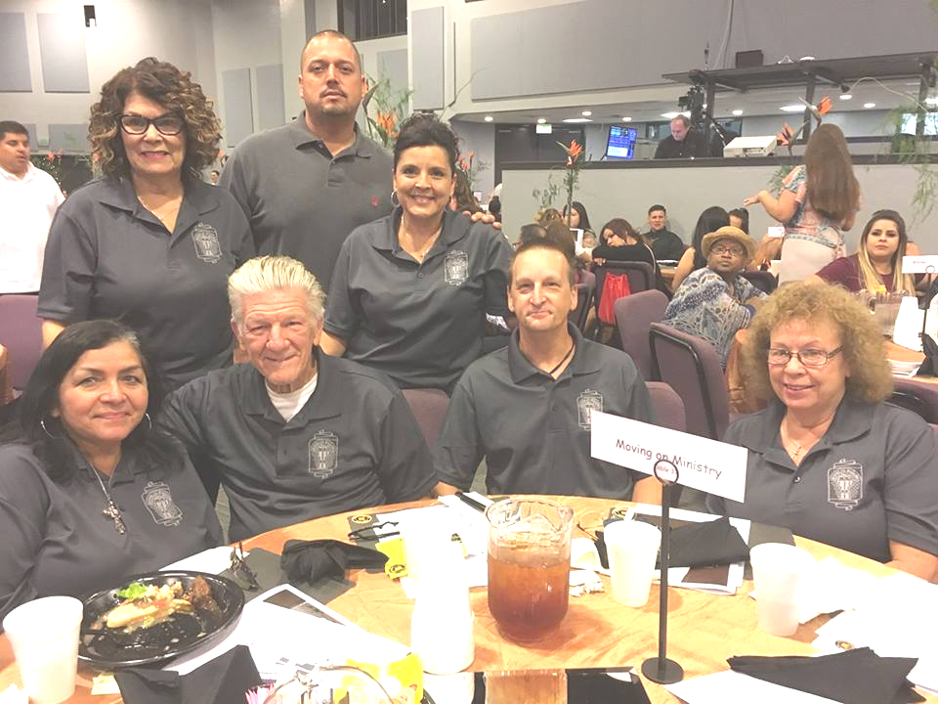

Front Row: Linda& Chaplain Bob K., Eric , Bonnie H. Back Row: Beatrice S,, Ray,, Irie E,Missing:George C,Ramona C, Gabe J, Susan J, Omar, Isabel, Mike, Beatriz
Upcoming Testimonies of M.O.M. Volunteer staff;

( note from a message response....have permission to print😊)
Just so you know if it wasn't for you and then a few others that came along in the picture AFTER you I wouldn't even have any interest in doing what I’m doing. You see it was the moment when I saw you and by the time we were done with our conversation I said to myself "Wow! Whatever that is that she is on I want some of it!" Then I realized that the symptoms from the dope you were on was called THE LOVE OF JESUS. That’s when I began to see the difference between religion and THE LOVE OF GOD. Love will carry us through anything even when its painful. Thank you and Bob for being part of giving me that gift. I love 'yuns' forever. Aleisha
(Aleisha has been a very powerful encouragement to all she is in contact with.☺ God Bless you.....Linda)

The Lighter Side

Pecans in the Cemetery
On the outskirts of a small town, there was a big, old pecan tree
just inside the cemetery fence. One day, two boys filled up a
bucketful of nuts and sat down by the tree, out of sight, and began
dividing the nuts. "One for you, one for me. One for you, one for
me," said one boy. Several dropped and rolled down toward the
fence.
Another boy came riding along the road on his bicycle. As he
passed, he thought he heard voices from inside the cemetery. He
slowed down to investigate. Sure enough, he heard, "One for you,
one for me. One for you, one for me." He just knew what it was, so
he jumped back on his bike and rode off.
Now just around the bend he met an old man with a cane,
hobbling along. "Come here quick," said the boy, "you won't believe
what I heard! Satan and the Lord are down at the cemetery dividing
up the souls."
The man said, "Beat it kid, can't you see it's hard for me to
walk." When the boy insisted though, the man hobbled to the
cemetery. Standing by the fence they heard, "One for you, one for
me. One for you, one for me..." The old man whispered, "Boy,
you've been tellin' the truth. Let's see if we can see the Lord."
Shaking with fear, they peered through the fence yet were still
unable to see anything.
The old man and the boy gripped the wrought iron bars of the
fence tighter and tighter as they tried to get a glimpse of the
Lord.
At last they heard, "One for you, one for me. That's all. Now let's
go get those nuts by the fence and we'll be done."
They say the old man made it back to town a full 5 minutes
ahead of the boy on the bike!

**********************************************************

Testimony
Hi Brother and Sisters, how are you today?!
I’m here before you to share my testimony, the testimony on how I found Christ, how Christ rescued me and profoundly changed my Life!
It all starts off since childhood and on how I grew up to this point in my life that I am here before you all. Throughout all of my lifetime I suffered much violence and abuse, physically, mentally, emotionally and spiritually. But through all of that violence I also experienced genuine love through my aunt, grandma and uncle. I got to know both sides of the world like the both sides of a coin. One side pure evil and wickedness and the other side was Genuine Love, Compassion, and Understanding. I was taught moral standards of Jesus growing up on the religion I grew up with my family, but………… Sadly I learned of evil acts through my life
experiences with sin of this world. ☹☹☹ Because of this I had many mislead directions that led me to practices of many religions that had nothing to do with the Lord, but instead with the evil one of this world. From that point of my life forward, my life started this path of downward Spiral of Darkness, a feeling of Empty Void in my Heart! “As I was sitting in Darkness, in that utter Darkness, a prisoner suffering in Iron Chains” (Psalms107:10).
As I was being blinded by the Veil of Darkness, I started to have a very bad misconception of right and wrong, and… I began to play judge on everyone in the world. I started to literally think right was wrong and wrong was right. I believed eye for an eye, tooth for a tooth was right, being with multiple relationships was right and getting vengeance on evil people for their evil acts was right. Even though I never got addicted to drugs, get drunk on alcohol and be in a gang I thought I was being righteous because of those facts and I would punish Evil when I should’ve been judging and examining myself instead of playing judge on others. I was just living in great Sin! How foolish I was! “I was leaning on my own understanding and wisdom, instead of giving it to God and staying away from Evil” (Proverbs 3:5-7)
The more I kept spiraling down into the void of Emptiness the more I was losing my moral standards then losing myself to Sin and causing me to be further away from God. I got so lost in my own despair, pain and emptiness that I got to a point I didn’t care about anything anymore. I didn’t care about people, about animals, about friends, family, not even for myself. I had no regards to human life, for I felt, “If Life don’t care about me then why should I?” Man, how much more foolish could I have been but little did I know someone Mighty did Love and care about me! I tried to find happiness in my own ways first by coming here to California, connecting with my father and getting to know the father I never knew my entire life. That didn’t make my life any better. My heart did not get filled with happiness. It still felt like an empty void with only a partial contentment of false happiness. I tried traveling and doing different jobs even illegal ones that made me feel important for a period of time but that still did not give me happiness. Then I thought I found my happiness through this girl that became my fiancé in time, she went through a lot of horrors in her life as I did which made us have a connection by the many things we had in common. All of her family and my family were happy that we were happy and that we were going to get married, but….. that happiness only lasted a short time. All of this is true…… “for we all have sinned and fall short of the glory of God” (Romans2:23). ☹ ☹ ☹
Soon after a while that everything seemed going so well, I ended up in jail the last place I would ever think I would end up at. I couldn’t believe it; I couldn’t believe this was happening. ☹ ☹ ☹ Everything I was feeling inside my heart has finally manifested into my reality! My heart felt emptier than ever before. I was just surrounded with loneliness and darkness in a small room that just kept me in that constant feeling every day. While being in there for the first 6 months, it was horrible and I would pray to God to help me in my current situation, but,…. I was doing it all wrong because I would also pray to the Virgin Mary. One day my cellmate and I were talking about God and told him I prayed to God and the Virgin Mary and that they were going to help me out. My cellmate was shocked and told me I was wrong on doing that and I shouldn’t be praying to her but only to Jesus and I got bothered by what he said. Later that week he brought me a magazine called “Angel of Light”, this magazine showed me through the testimony of 2 men, using the facts of who Satan is through Scripture, on how Satan Steals, Kills, and Destroys by his lies and his manipulation on people to make us stray and stay away from God through T.V., Music, Movies, Religions and any means necessary. When I read all of this, God removed the veil of Darkness out of the eyes of my Heart and I was in total Shock and disbelief. I couldn’t believe that Satan had kept me in the darkness for so long making me serve him. I felt like a total fool “he has driven me away and made me walk in darkness rather than light” (Lamentations 3:2). Yet, through this shock of truth I felt happy in the weirdest way. From that point on I grabbed 5 different Bibles, laid them all on my bed and prayed to the Lord to show me the true and false Bibles. So I started comparing them all to find which is which. I got even more shocked on what I was reading and how different they were to each other. Three out of the five where false the other 2 were consistent to what they were saying even though they were 2 versions of the same content of the Bible.

Ever Since, the Lord has revealed His Light to me “I saw that wisdom is better than folly, just as Light is better than Darkness” (Ecclesiastes2:13). The Lord has revealed to me everything on who He is and who I was to myself before Him. I was made aware and realized how wretched, wicked and evil I truly was. ☹ All my self-revelation made me feel stupid, unworthy, disappointed and angry on myself on how horrible I’ve been acting towards God and everyone else in this world. God made me aware of all my sins I have committed before Him, “all of my unrighteousness, all of my deceit, all I said from my poisonous lips, all my swift feet for blood shed, not knowing the walk of peace because there was no fear of God before my eyes”(Romans3:10-18). Because of my stupid sins, I was dead in my transgression for following the ways of the world being controlled by the prince of the air and out of the desires of my own flesh. (Ephesians2:1-3).
After all of this awareness of myself as a wretched and messed up sinner, it made me Repent super hard before the Lord and confess in all the ways I have sinned (Leviticus5:5). I cried and begged God to forgive me as I confessed all my stupid sins before Him. I begged Him to please forgive me even the sins I could not remember. After my full repentance I declared out of my mouth that Jesus is the Lord of my Heart, Mind and Soul and believe in my Heart that He died for everyone on earth, and God our Farther in Heaven, did raise Him from the dead so everyone who believes in Him can be saved and come before God! , especially me through Jesus Christ because He is The Way, The Truth and The Life! (Romans10:9 and John14:6).
After Knowing the Truth of who Jesus truly is, it was a huge awakening for me knowing Jesus as not being tempted by nothing in this world it’s crazy but amazing at the same time. Because one thing I do know as a human and knowing Jesus being fully man as fully God, He was tempted like we all have been tempted in all the areas of temptation, but HE did Not Sin! He did Not fail on His mission on earth to Pay my debt with His blood, took my punishment of my sin and died in my place, He did this for me, He did this for you all and for the Entire world! I can finally say I became free from the chains of sin, because the Truth literally did set me Free! (John3:19). ☺ ☺ ☺ ☺
Everything that I felt, praise the Lord, Worship Christ with the best of your portions, I know I won’t forget all He has done, He’s the strength in this race that I run, Every time I look up I see God’s faithfulness and it shows just how much He is miraculous, I can’t keep it to myself, I can’t sit here and be still, Everybody, I will tell ’til the whole world is healed. King of Kings, Lord of Lords, all the things He has in store, from the rich to the poor, all are welcome through the door, You won’t ever be the same when you call on Jesus’ name. Listen to the words I’m saying. Jesus saved me, now I’m sane and I know. I know God is the force that picked me up. I know Christ is the fountain that filled my cup. I know God is alive, yeah, He has opened up my vision, giving me a revelation. This ain’t ’bout a religion, Jesus brought a revolution. All the captives are forgiven. Time is now to break down all the prisons, every man and every woman. There is freedom from addiction. Jesus, You, have my soul, Sunday Service on a roll, All my idols, let them go, All the demons, let them know this a mission, not a show, this is my eternal soul. This my Family, this my friends, this my house, this my life, This my God-given right.
Thank you, Jesus, won the fight. This is who God Is!
By Hector. A.

Note from Linda;
As I listened to Hector saying his testimony at church, I had tears in my eyes as to his long road and yet God made a way when he thought there was none. It is amazing what we realize during some of our rough roads we go through. I, myself, did not know until I gave complete control of my life to the Lord and FREEDOM to live until our time is done on this earth. Tomorrow is not promised. We can do it….but….we have to give in and choose JESUS. “ He is the Way, the Truth and the Life” for sure. God Bless Hector!) Linda@M.O.M.

*******************************************************************

*******************************************************************
Followup Letter from Troy Root 1/12/20

Dear M.O.M.

Happy New Year. I’m writing back to you in response of your last letter. I’m so sorry for what happened with the money I was planning on sending to you. I’ve never got anything from my family. I’ve been shut out of everything. I guess because I’m a low life inmate and I don’t deserve anything. There was no worse pain than to have your family abandon you. I know Jesus loves me and that is all that even matters. Also I was never trying to deceive you or lie to you, so please believe me when I tell you I love you all.
I also jut got out of the hospital. I spent over 3 weeks in the hospital and another 9 weeks in ICU. I was assaulted here and my spine and liver were hurt. That is how I spent my Christmas, in the hospital. God always has a plan. This will all work out for His glory. Amen.
Also about the address lists, I’ve given them all out to other inmates because I have a good heart and I wanted to help them.
I’ll humbly ask this, will you please send me these items?
2 sets of your address lists
You have my word I’ll never ask you again for any more and these I’ll keep for myself, I promise.
Please keep me in your prayers for healing.
I truly thank you all for what you do for me and this will be the last time I’ll ask for these. Please send them as soon as you can.
Troy Root

2nd Followup Letter from Troy Root 1/19/20
Dear Bob and Linda,
I’m writing to you in sincere regret that I could not send the money I was planning to. I hope you still love me and care for me. My family has done me very wrong and it hurts bad. I also pray you’ll still send the 2 sets of your address list. Please forgive me. This was not my fault. Please write real soon and send the address lists. Troy Root
********************************************************************************************

(Very much appreciated this part of a letter from Michael S.)

Thank you for taking the time to write me out of the busy day you must have and thank you for your volunteers. ……..
…… Please give Bob a big hug for me and let him know that the Ministry that God gave to the “Both” of you has been a wonderful blessing to many prisoners…
With much love and respect. Michael A. Serrato

(the letter was longer but just wanted to share this part/blessed*)

*******************************************************************************************
(Another blessed encouraging letter from Valentino.)

I am still here in Madera doing the will of Jesus Christ as His prayer warrior and the Lord's children come first in my day. For those here fighting trials and tribulation seeking for understanding and companionship and loving on them as their Godly brother and praying on them for their cases, family and salvation. I give them my testimony that the Lord prepared me to give to them.

In 1992 I was shot in the head three times, 10 percent of my brains cut out of my head, two times in my left arm, one time right in my head, one time in my heart and once in my left leg and the Lord pulling me from death's door to be proof of the Lord's Mighty Hands and Miracles that He does for us. I'm 90 percent blind out of both eyes. I see shadows and I walk in blind faith. I see shadows and I walk in blind faith for the Love of Our Father Jesus Christ yes the Lord has me walking so professional that others can't believe I'm blind. The Lord has been using me in and out of jail and prison to speak His Holy Words of Life to all his children that the Lord restores, forgives and uses us for all His Glory. My wife Grace died from cancer yet came alive in the Spirit of Jesus Christ and now is in Heaven with our Father Jesus Christ. We both surrendered to Jesus in 06-18-12 and Grace went home to Jesus on 08-18-12.

I've been doing the Will of God yet the enemy sets us up and we are judged from our past. The Lord has been using me as His Filter to restore and renew all His loving children in ministry and through sinner's prayers so we may be saved by our Father Jesus Christ.

Thank you for the Newsletter #107 and I pray to be used in your mission to help and provide all my love and assistance. I'm 50 years old and well alive in our Father Jesus Christ. I've been baptized and God willing ordained as well......
Love you,
Brother Pastor Valentino Torres, PRAYER WARRIOR....AMEN....WOOO HOOO,
The blind will lead the blind man. Love you Bob and Linda. woo hoo. : )

