Volume 101

Apologies!!
We are very late getting out the M.O.M. newsletter. We know how much you look forward to the publications. Bob and Linda have been overrun with mail and updates for the mailing and profile lists. Bob has been typing the articles and the newsletter for each issue. Beatriz has been doing the birthday cards and Linda and Bob read EVERY letter received. We appreciate the prayer and all the things the inmates send us. Truly the little things become the big things and the big things become the little things.
Bob, Eric, George, Irie and Beatriz have been heavily involved with support of the Bill Glass Ministry. We have also added a new volunteer that is going to be a Great addition – Please send a Greeting to Bonnie. Also keep singer Heather Layne in prayer as her family and she have returned to California from Kansas.



Bob is also trying to develop sales for his Lamborghini Diablo 6.0 replica business to help with expenses of M.O.M. M.O.M. is financed primarily from the donations of its volunteer staff.

“Letter From M.O.M.”

Volume 101

Quarterly newsletter of Moving On Ministry

WWW.MovingOnMinistry.com (Since April 2001)
www.PrisonMinistry.net/movingon

Volume 101 –July / Aug / Sept 2018 (Published since Oct. 2003)

************************************************************************

“I Can Only Imagine”

As you receive this volume of Letter From M.O.M., we are continuing with more of the testimonies of “How God Changes Lives” as well as some more of our own written articles. We can truly say that the “high” that many of our inmates have been trying to get through the wrong methods, is being surpassed by those putting God in ownership of their lives.

Watch our website www.MovingOnMinistry.com

We are also affiliated with International Prison Fellowship
www.PrisonMinistry.net/movingon

Fellowship

With the crashing of the computer, we are building a new mail list. We got behind on letter replies, and may occasionally miss one. Please write back if we do not answer, and write clearly so we can get the mailing information correct.
$100 M.O.M. extended Logo Winners on Page 9
Intentions & Wishes

The intentions of this newsletter are to allow an understanding of jail & prison ministries. It is our intentions to get input from those incarcerated as well as those “free” to visit. Life experiences of the faith and fellowship from those locked up in the facilities are always desired to let others know of the value of “visitation”. I am certain that each of us have many stories of the miracles God has done in our lives.
Our wishes are that we would have a list of supportive churches and programs that individuals might look forward to attending, once released.
A list of services, such as housing, employment and counseling services, as well as some individuals available for friendly fellowship are also much needed items (Resource List).
God’s Word says if a man stumbles, how can he continue lest there be another to help him up. Ecc. 4:10 “For if they fall, the one will lift up his fellow: but woe to him [that is] alone when he falleth; for [he hath] not another to help him up.” Proverbs 24:17 “Rejoice not when thy enemy falleth, and let not thy heart be glad when he stumbleth:” John 11:10 “But if a man walketh in the night, he stumbleth, because there is no light in him.”
Please help us with input for this newsletter as we strive to serve God. We appreciate any articles or input.

Pray for volunteers with the same passion as Bob, Linda, Eric, Irie, Ray, Jacob, Savannah, Beatriz, Bonnie and others of our current volunteers have.

****************************************************************************************
Many are familiar with the 56 page “Resources From M.O.M.” that has approximately 650 listings in various categories (downloadable online).
Can mail with 6” X 9” S.A.S.E, and $ .94 postage and $ .98 copy fee. If using #10 envelope, postage is $ 1.26

For individuals being released to one of California’s 58 counties, there are internet listings of services and programs available. Have a loved one print them out.
http://www.cdcr.ca.gov/Community_Partnerships/Resource_Directory.aspx

http://www.cdcr.ca.gov/Community_Partnerships/SearchByCounty.aspx?ct=??????

The areas of Service listings are as follows;

Adult Services
AIDS/HIV Services
CDCR Contracted Services
Child Care Services
Child Support Services
Clothing Services
Counselling Services
Disability Services
Documentation & Identification
Domestic Violence Services
Education Services
Emergency Services
Family Services
Financial Services
Food Services
Gender Specific – Female
Gender Specific – Male
Homeless Services
Housing Services
Legal Services
Mental Health Services
Mentoring Services
Native American Services
Physical Health Services
Police / Sheriff / Parole
Referral Services
Religious Services
Substance Abuse Treatment
Tattoo Removal
Transportation Services
Veterans Services
Vocational Services
Volunteer Services

------------------------------------------------------------------------------------------------------------
Copies at $.07 per page and send S.A.S.E. (# 10 envelope for up to 30 pages, 6 X 9 for up to 50 pages / 9 X 12 for printouts above 50 pages) Flat Rate Envelopes (12-1/2" x 9-1/2" or smaller): $5.75, Small Flat Rate Box: $5.95, Medium Flat Rate Boxes: $12.65

Postage (up to # pages)

****************************************************************************************

Addresses to contact the Ministry Volunteers

Keep Believing Ministries
P.O. Box 257
Elmhurst, IL 60126

Calvary Chapel Prison Ministry
Attn: Carmine Aleprete
P.O. Box 1965
Big Bear Lake, CA 92315

Otto & Jennie Ball
c/o Crossroads Ministry
P.O. Box 363
Hyde, PA 16843

LaVoz de La Esperanza
101 W. Cochran St.
Simi Valley, CA 93065

Set Free Prison Ministries
Bible Correspondence Course
P.O. Box 5540
Riverside, CA. 92517-9986

Jesus People Info. Center
4338 Third Avenue
Sacramento, CA 95817

Crossroad Bible Institute
P.O. Box 900
Grand Rapids, MI 49509-0900

Ministero de Prison
P.O. Box 543
Live Oak, FL 32064

El Concilio Del Condado
301 So. C St.
Oxnard, CA 93030

Marlene Henderson
P.O. Box 1315
Westville, OK 74965-1315

Little Lambs, Inc
John & Eileen Sala
P.O. Box 32
Sebring, FL 33871-0032

3 G Company
Correspondence & Freebies
P.O. Box 1022
Canfield, OH 44406

Iglesia Puerta de Salvacion
202 Lafayette Ave.
Lindsay, CA 93247

World Challenge
P.O. Box 260
Lindale, TX 75771-0260

The Felony Foundation (TFF)
P.O. Box 190806
Dallas, TX 75212-0806
(Pen-pals)

International Prison Ministry
Bible, Dictionary, Concordance
P.O. Box 2868
Costa Mesa, CA 92628-2868

Missing M.O.M. ?
We must constantly remind individuals that we need to be notified of changes of address or facilities. If we get returned mail (about 20 each month), we remove that individual from the files. If you have, or you are going to be moved, please drop us a note to keep your file active. We get mail returned for bad ID #’s, no cell #, and no bed #. Make sure that your return address is inside the envelope as well as on the envelope – we get many damaged envelopes that are unreadable.
*********************************
Letters that Express it All
We like to post real life situations, because God works in real lives and He is the one that gives “Eternal Life.”

*********************************
Sharing Your Testimony

*********************************
There are 4 parts to an individual’s testimony;
- What my life was like before I met Jesus.
- How I realized I needed Jesus.
- How I committed my life to Jesus.
- The difference Jesus has made in my life.
The importance is not what you have done, but what God is doing.
- Your testimony Your life lessons
- Your godly passions
- The Good News

For those of you that communicate with individuals that have computer access, we have added quite a bit to our web site. The “Resource List” (56 pages), ALL past newsletters (“Letter From M.O.M.”), inmate lookup links, and artwork are available to be viewed or you may download.
www.MovingOnMinistry.com

I would like to add that we have shared many wonderful testimonies. Many individuals are afraid to share their testimony because they are not sure what to write or feel inadequate in their writing ability. God’s Word says in Jeremiah 17:9 that “the heart is deceitful above all things, and desperately wicked: who can know it?”

*********************************
PLEASE Pray that the churches, friends and relatives of inmates would become supporters of this Jail/Prison ministry.

We have downsized the mailing list according to those responding with profile sheet updates
We have dropped to getting 60 to 100 letters/requests per month. Let those on the outside know of how much good M.O.M. does for inmates.

In continuing with Linda’s love for animals, (see volumes 97 & 99). we offer the following story

Sheriff Joe Arpalo vs. Politics And Dog Killers

AZ Senator (R) Jeff Flake’s son charged with felony animal cruelty in the gruesome death of 21 dogs, 2017 election repercussions, Sheriff charged with Criminal Contempt, and a sad reflection on the news media.

January 2018
Courtesy TheDogPress.com Staff
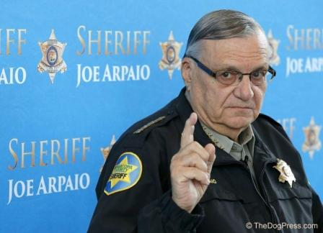
As 2017 drew to a close, AZ news media erupted with “Former Arizona Sheriff Joe Arpaio …accused by son of Sen. Jeff Flake, R-Az…” What? You are about to see how “mainstream” media” works.

First, some background.

AZ Senator Flake’s son, Austin Flake and his then-wife Logan Brown filed a malicious prosecution lawsuit against AZ Sheriff Arpaio in 2015 alleging Maricopa County Sheriff Joe Arpaio maliciously targeted them with felony animal cruelty charges.

21 dogs died while Austin Flake and his wife were taking care of things for her parents, who owned a boarding kennel. Making the tragedy even worse, distraught dog owners were told that their dogs somehow “ran away”. But Sheriff Joe, known as an animal lover who once housed shelter dogs^{{1}} in his air-conditioned Maricopa County jail, said "They didn't run away. The dogs are dead."
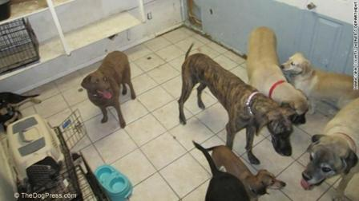
He was right and worse yet, the dogs died from neglect as was obvious when owners discovered “20 dogs dead or dying in a small shed next to the Hughes' home.” The media reported the dogs died of heat exhaustion in an 8x12ft room “after a dog chewed through the air conditioner's power cord during the night.” Whether in the kennel building with A/C or in a small shed, ultimately the dogs died a horrid, tortuous death.

Partisan politics and the news media had a field day until the building owners (Austin Flake’s in-laws) made the felony animal cruelty charges go away by taking responsibility, agreeing that they “did not properly maintain the air conditioning unit ventilating the dogs' accommodations.”

But the “other side” wasn’t through with Sheriff Joe Arpaio. The odds-on favorite to be re-elected to the post he had served for 24 years, he was slapped with criminal contempt charges because he refused to obey a judge's orders to stop enforcing federal immigration law! Whether this was a get-even retaliation by Austin Flake’s father, the powerful Senator Flake, or just exaggerated political correctness, Sheriff Joe lost the 2016 election to Democrat Paul Penzone.

If Arizona voters believe we should welcome everyone to our country including indigent people tax-payers have to support, that is their right. But are those the same kind-hearted people who would send an 85 year old law officer into the hands of the criminals he caught and put away?

Thankfully, President Trump pardoned Sheriff Joe Arpaio in August 2017. And on Oct. 24, Senator Jeff Flake announced he would not seek re-election. The Republican Senator had “sparred frequently with President Donald Trump” and in his departure speech he said there is a ''flagrant disregard of truth and decency.'' Ironically, people on both sides of the political aisle would agree.
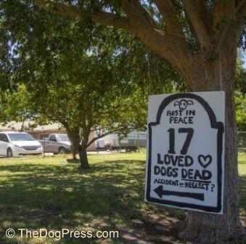
There is one final lesson to be learned about the state of American politics. This dead-dogs-felony cruelty happened nearly 4 years ago but The Washington Examiner, in apparent reaction to the President’s Pardon, blasted this headline on Nov 24, 2017, 5:16 PM “Joe Arpaio accused of charging Jeff Flake's son with animal cruelty to embarrass Arizona senator.”

Arizonians may have been duped once but he jury refused to award damages against former Maricopa County Sheriff Joe Arpaio in the civil trial. But just to prove you can’t trust a politician, on December 23rd, 2017 Fox News picked up Arizona Republican Senator Jeff Flake on a hot mike saying “If we become the party of Roy Moore and Donald Trump we are toast.” One of our staff, a Democrat, shook his head saying “You just can’t trust a politician.”

The end of this story is that finally, Sheriff Joe can relax and enjoy honorable retirement. TheDogPress.com is proud to have paid tribute to a law enforcement officer who loves animals and upholds the Constitution and the Rule Of Law.

************************************************************************
Contest - Design a “Moving On Ministry” (M.O.M.) Logo

- Entries must be hand drawn
- Entries should be on 8” X 10” <or> 8 ½” X 11” paper
- Entries must be received by July 15, 2018 (Judging night)

First place ---------- $100.00 on the books
Second place --------$ 50.00 on the books
Third place --------- $ 25.00 on the books

We have gone 17 years with the ministry (Now a 501 (c) 3 non-profit) and need a banner with a Logo to display at events we sponsor or attend.

******************************************************
Contest winners
1st Place - - - - Jack W. Friend (requested 2 Bibles)

2ND PLACE - - - - richard sanchez

3rd PLACE - - - - HAROLD J0HNSON

Honorable mentions (book of stamps):
- Jack W. Friend
- Donald Courville
- Jeremy Fifer
- Kevin Steen
- Obed Rodriguez
- Lance Earl Livingston
- Dale Fletcher
- Steven Stanley
- Joseph Dean Grierson

Artist = Jack W. Friend
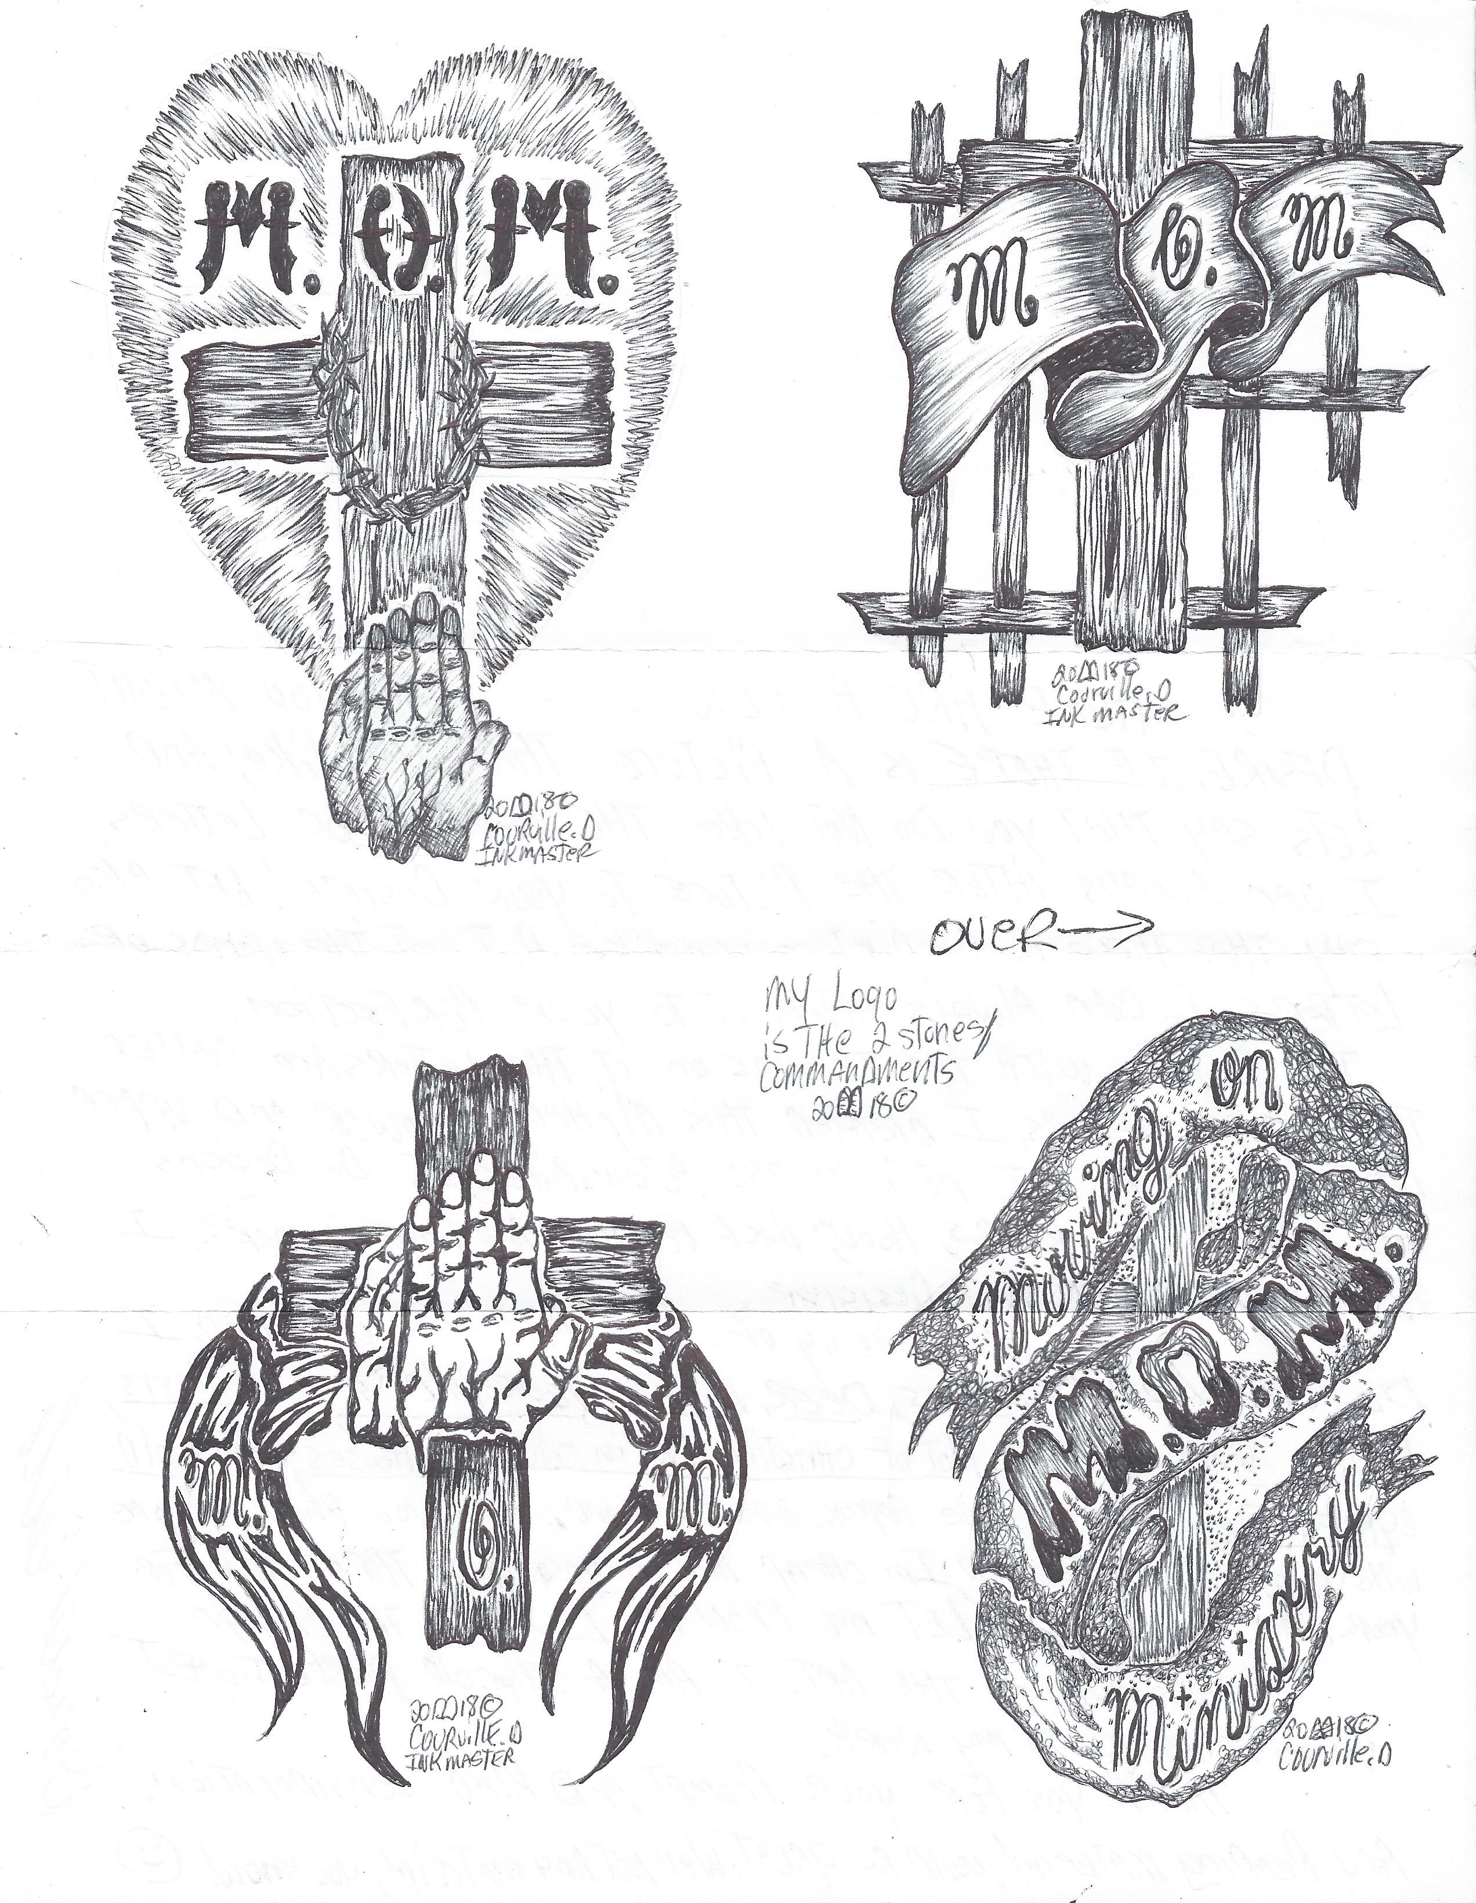
Artist = Donald Courville

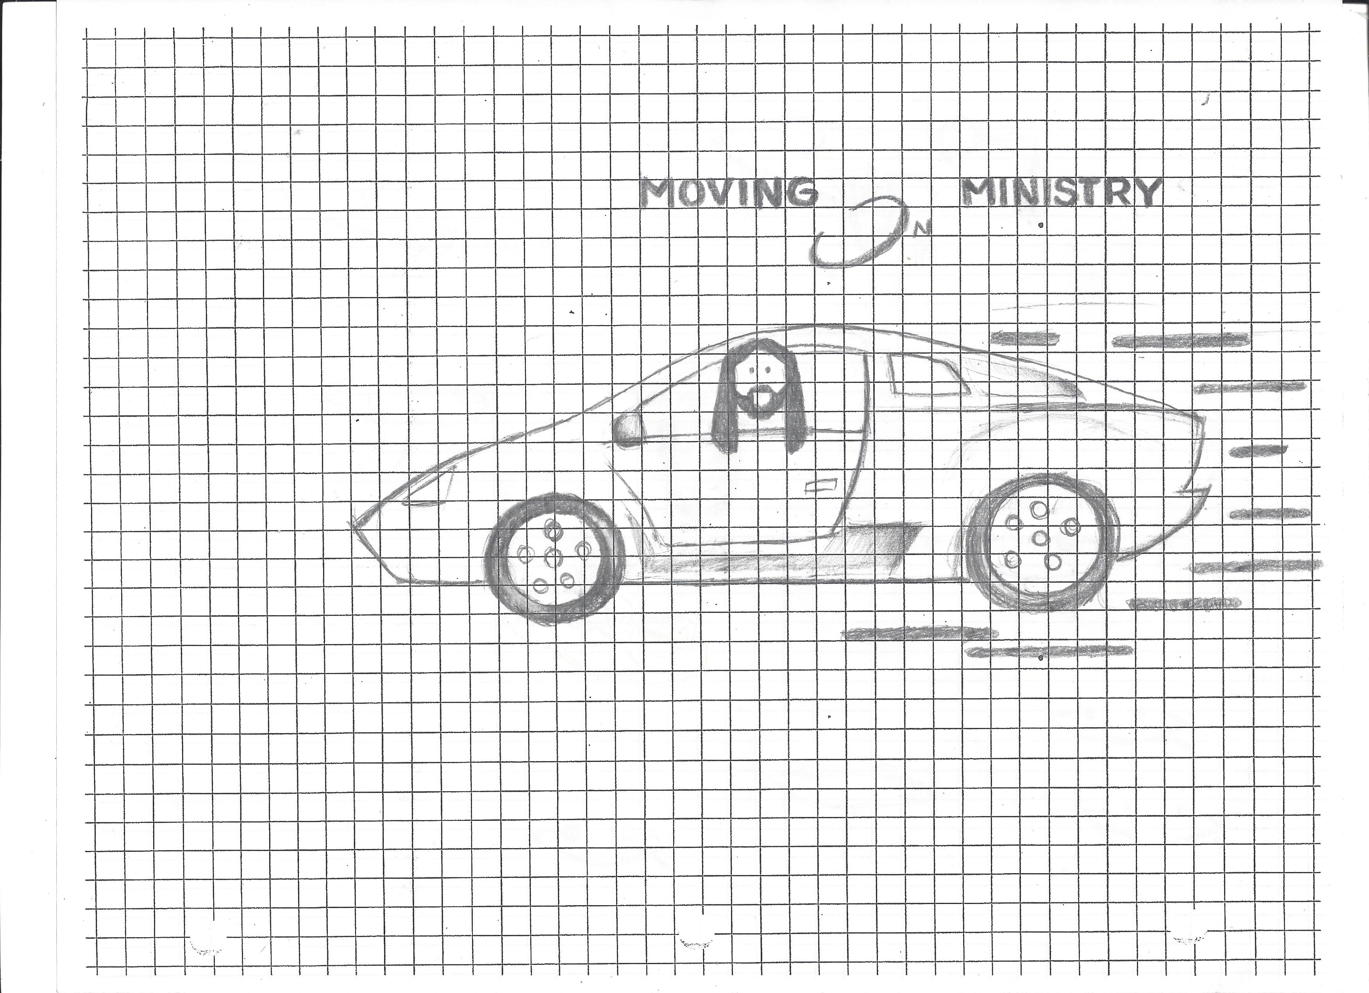
Artist – Jeremy Fifer
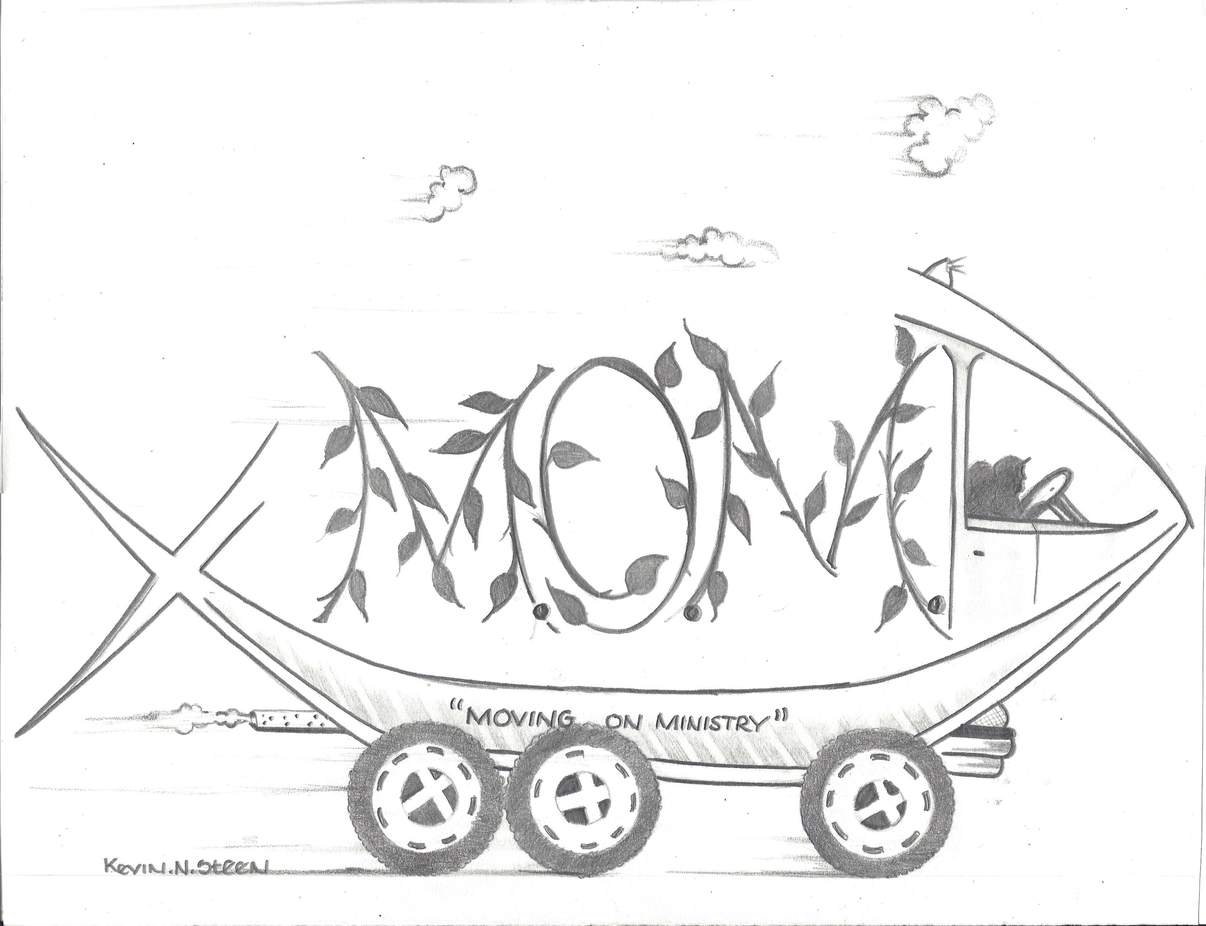
Artist = Kevin Steen
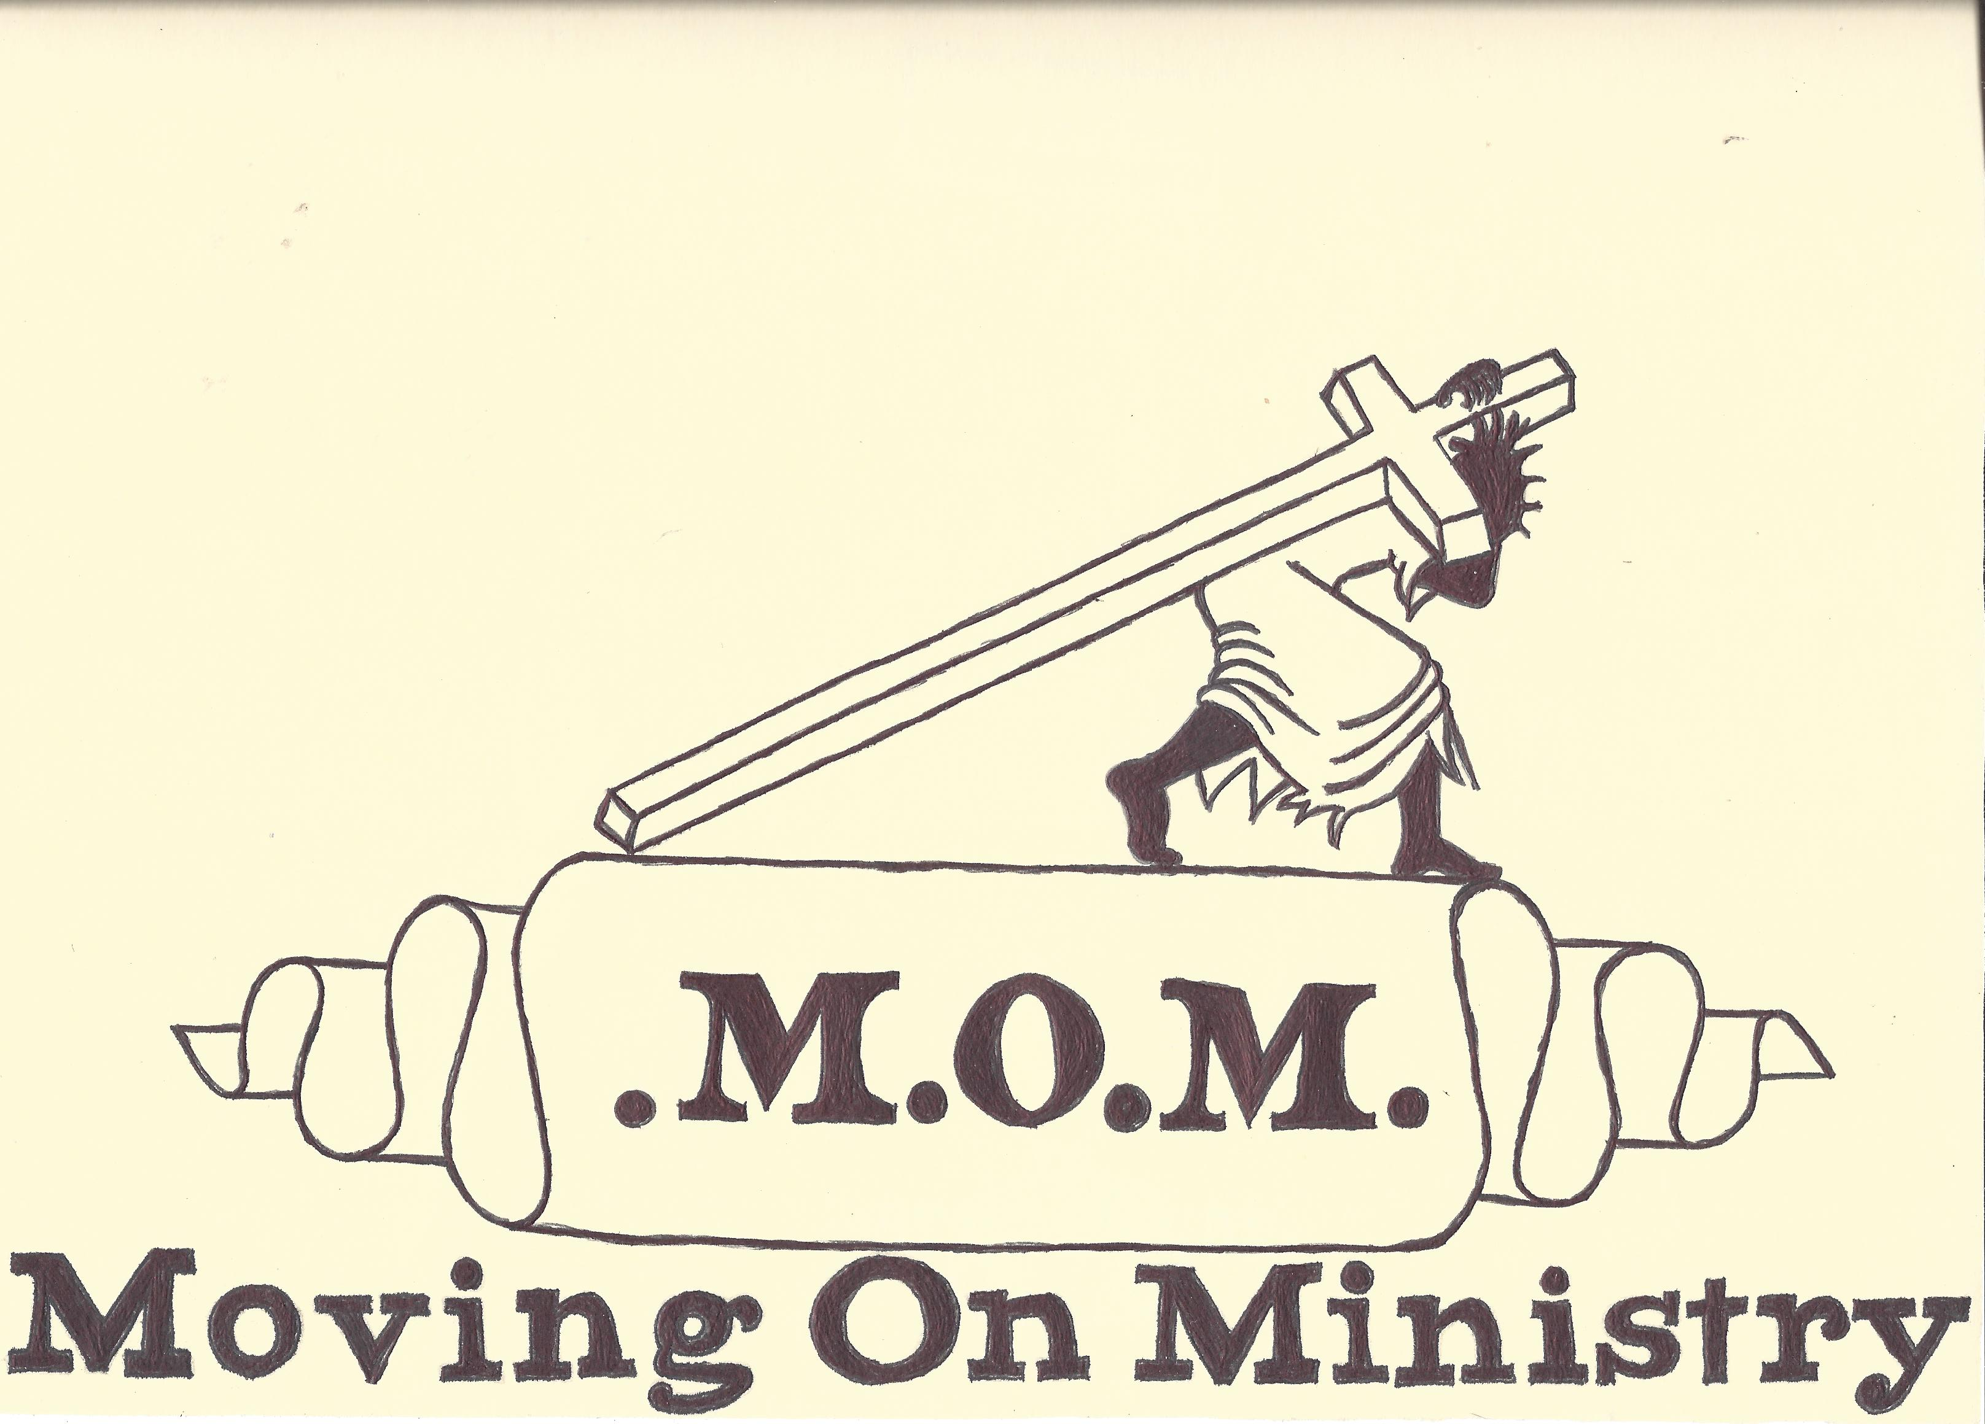
Artist – Jack W. Friend
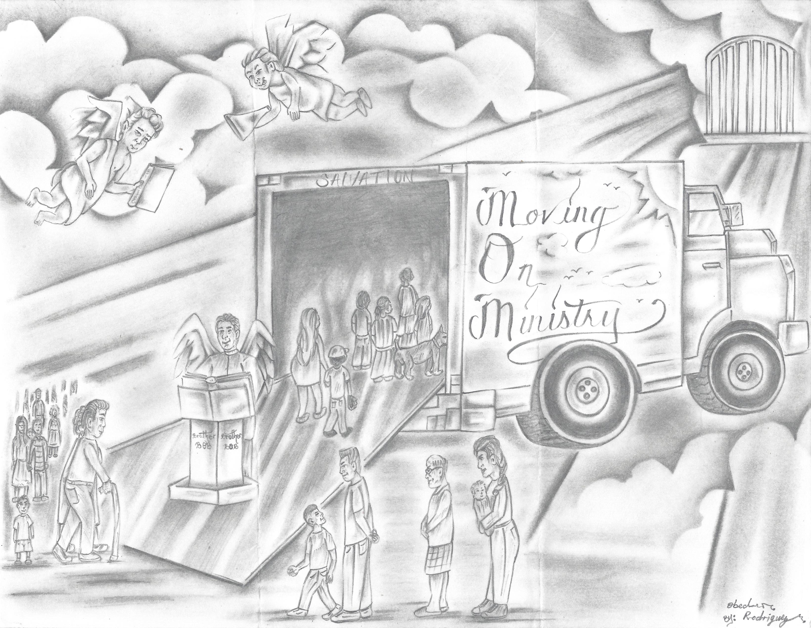
Artist = Obed Rodriiguez
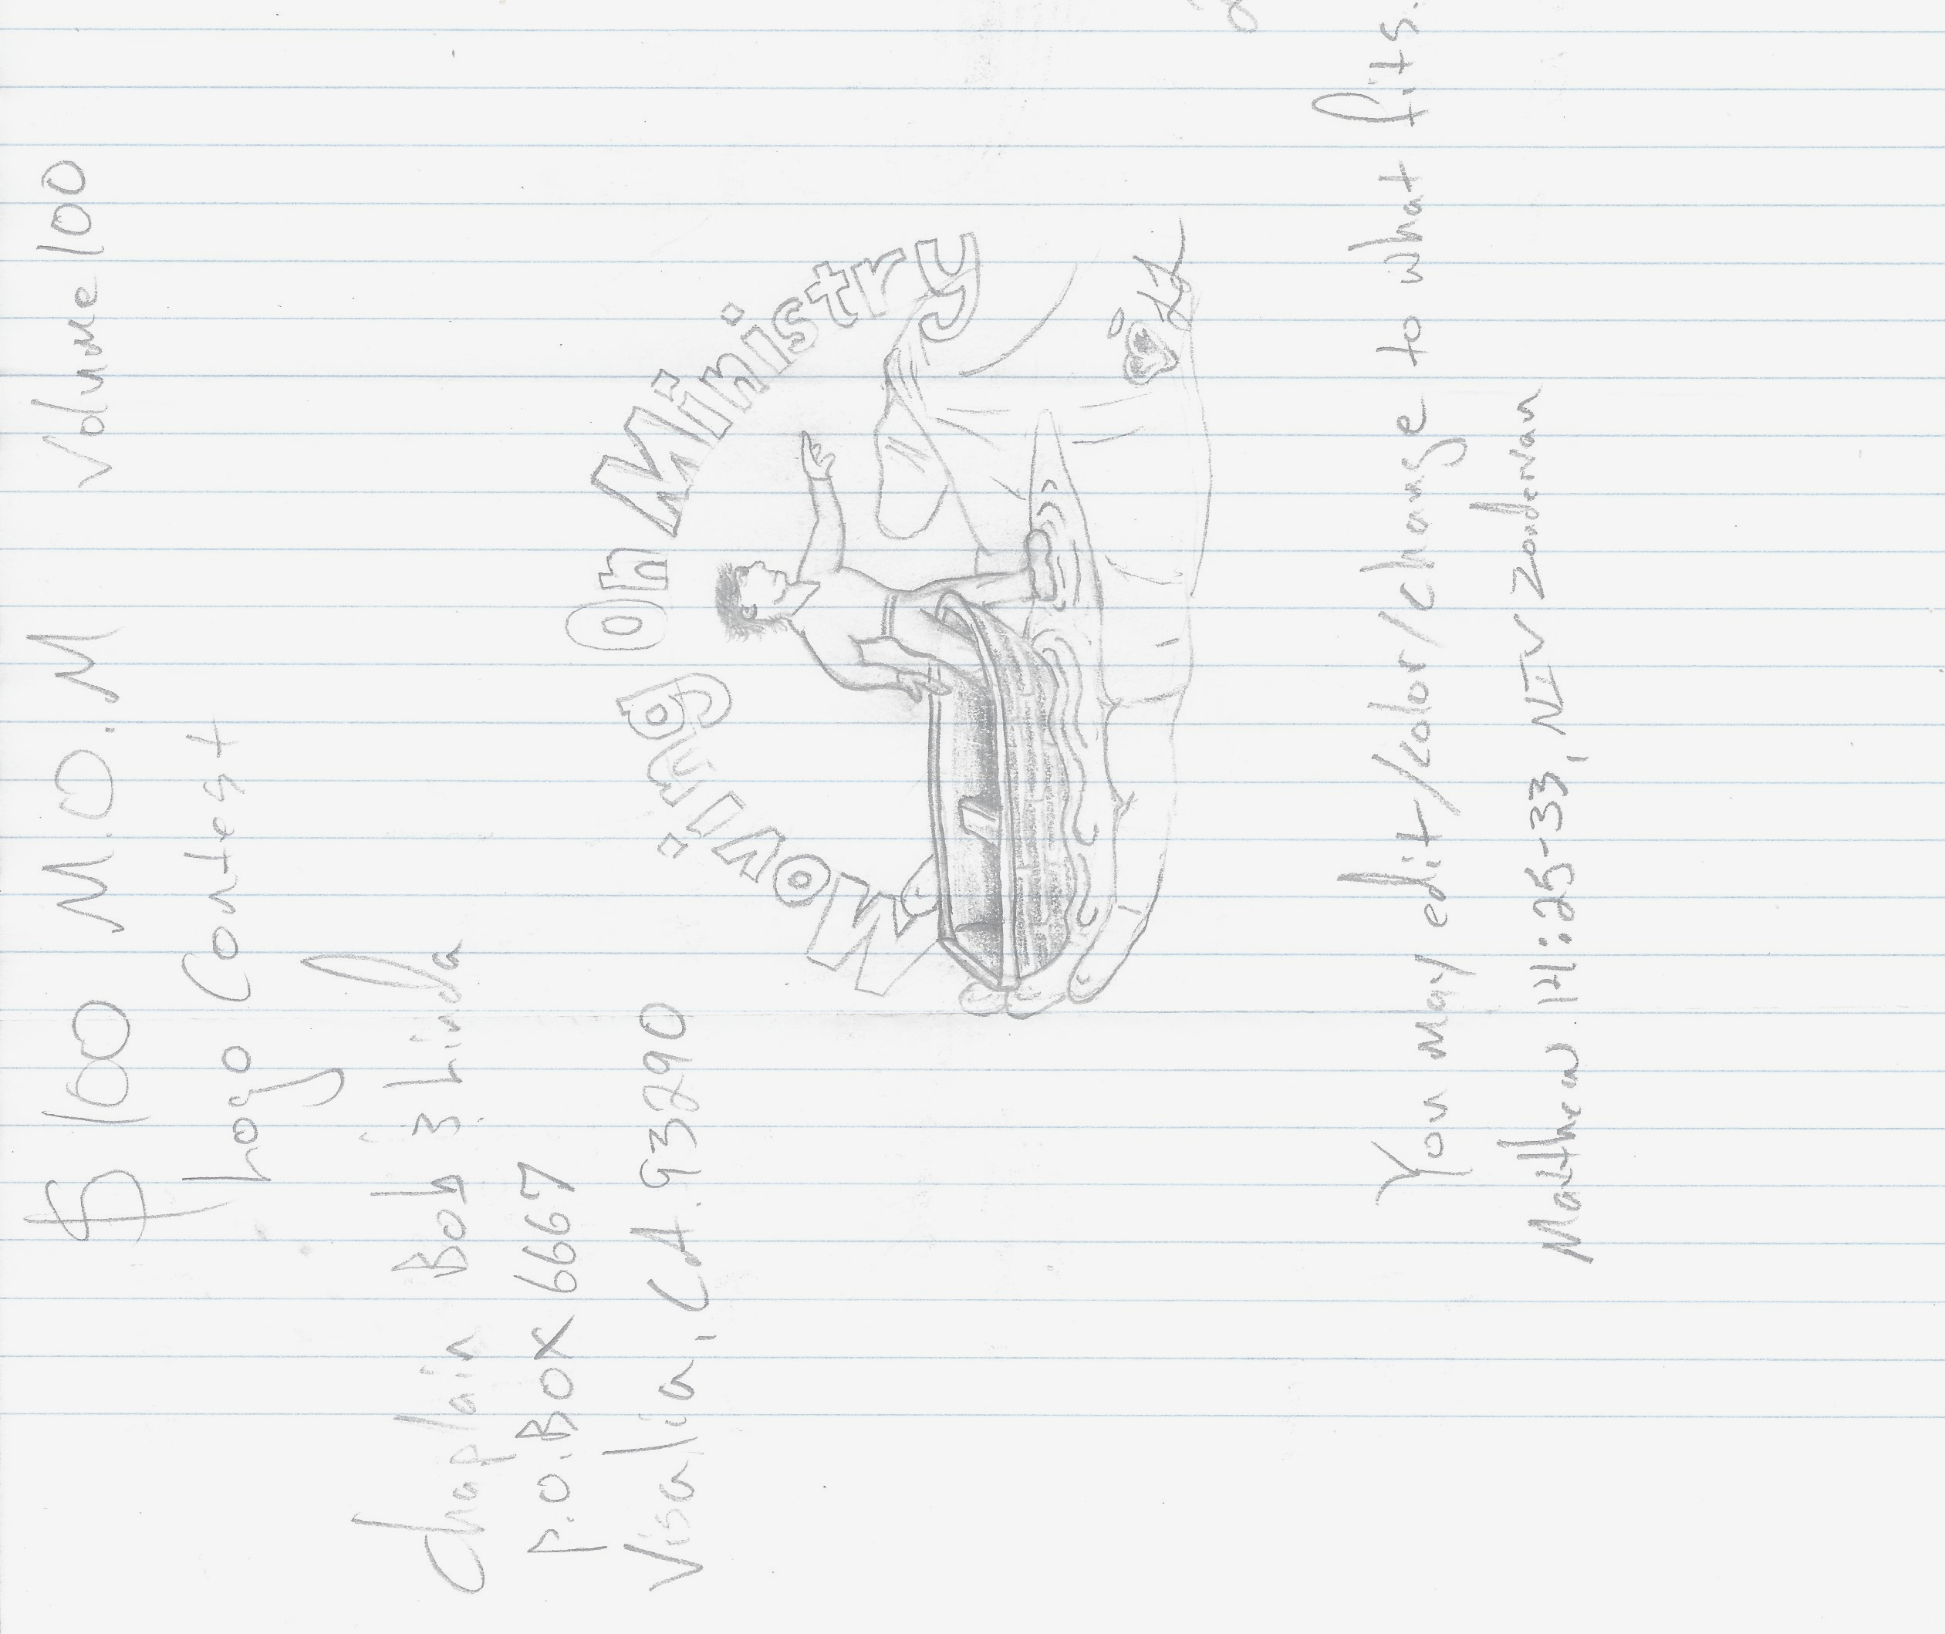
Artist = Lance Earl Livingston
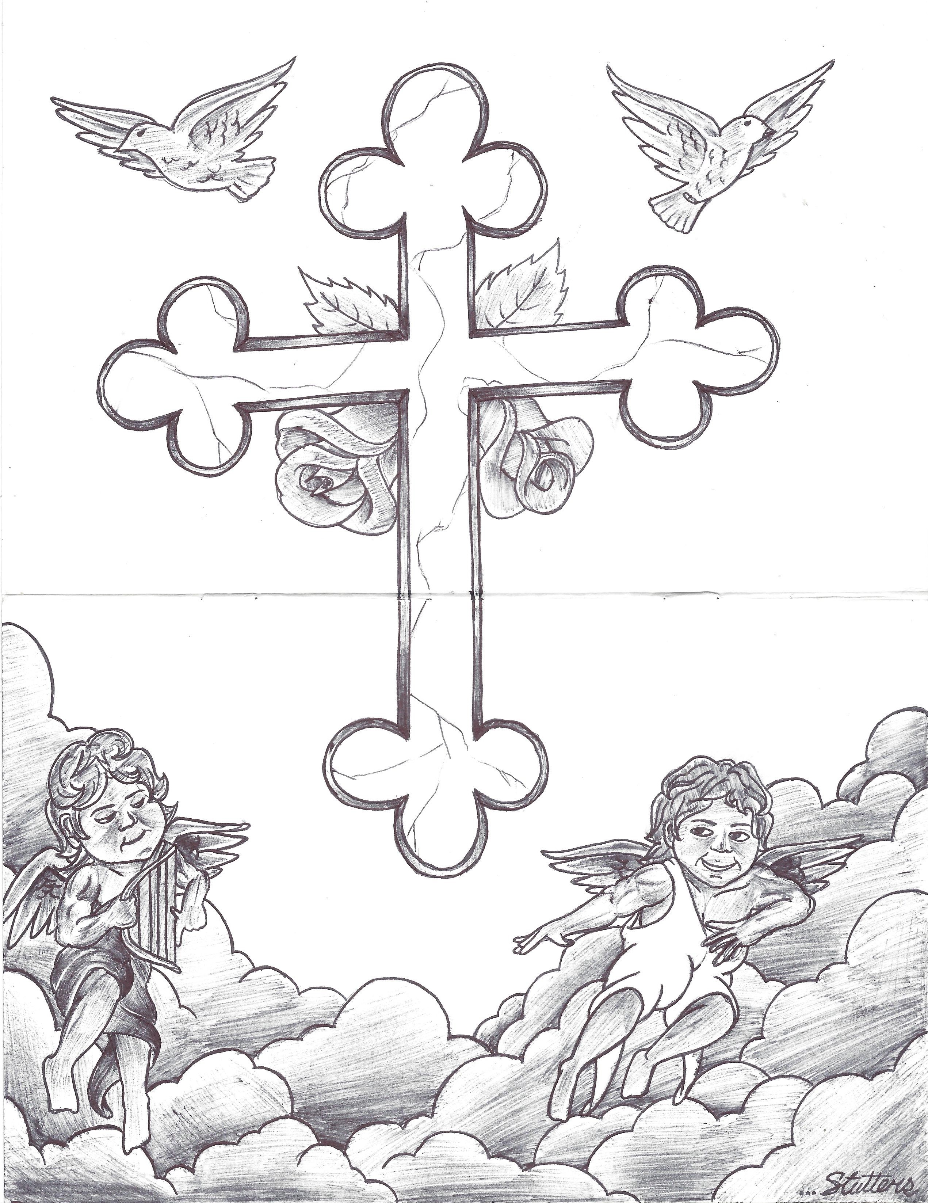
Artist = Dale Fletcher
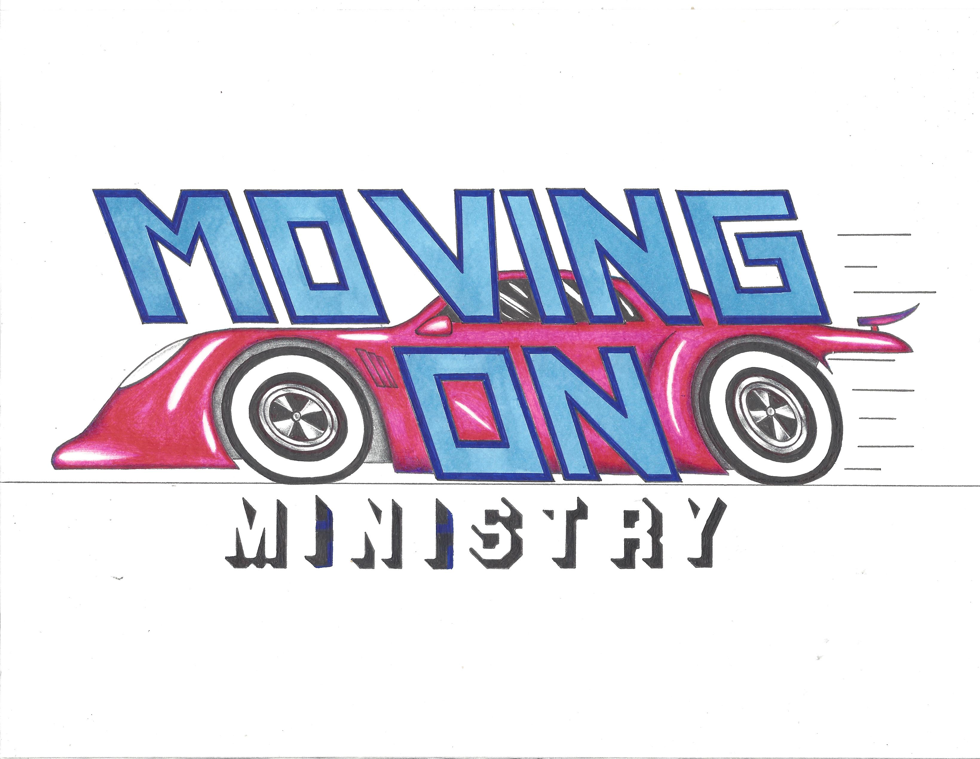
Artist = Harold Johnson – 3rd PLACE
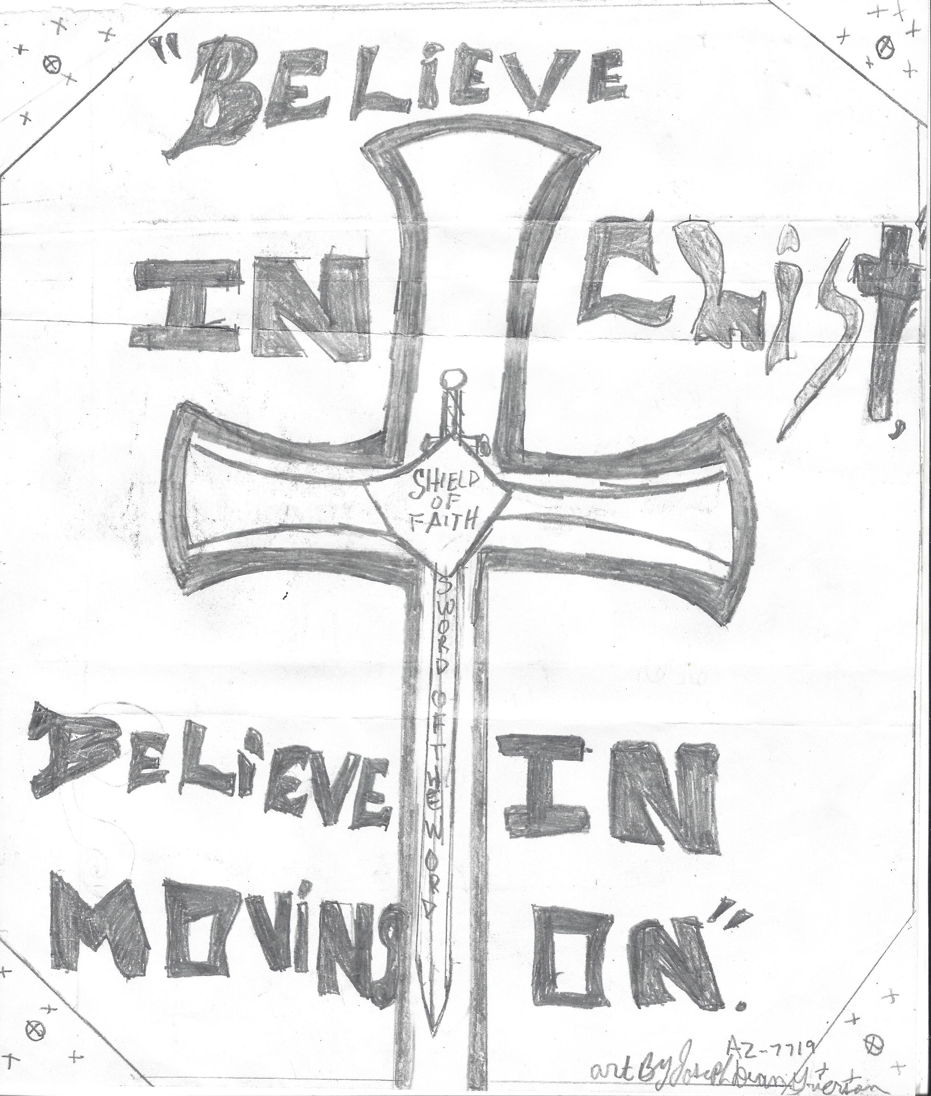
Artist = Joseph Dean Briarson



Artist = Jack W. Friend – 1st Place

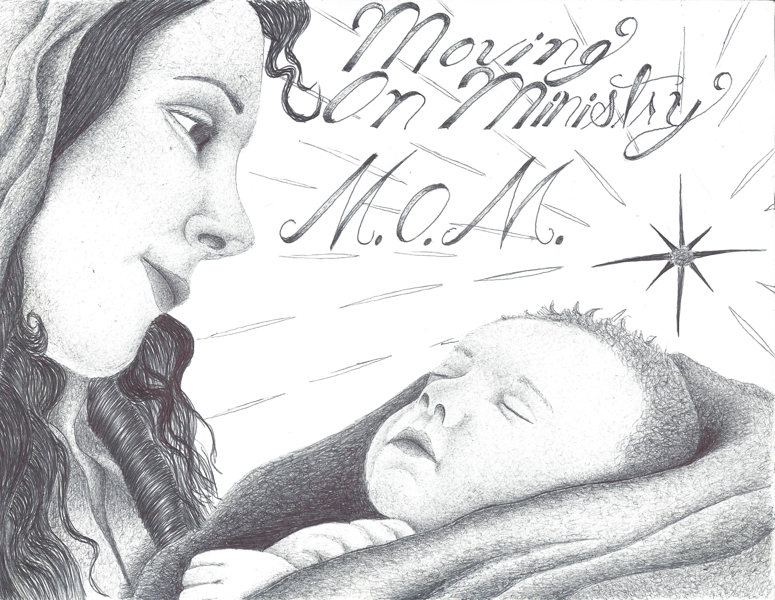
Artist – Steven Stanley

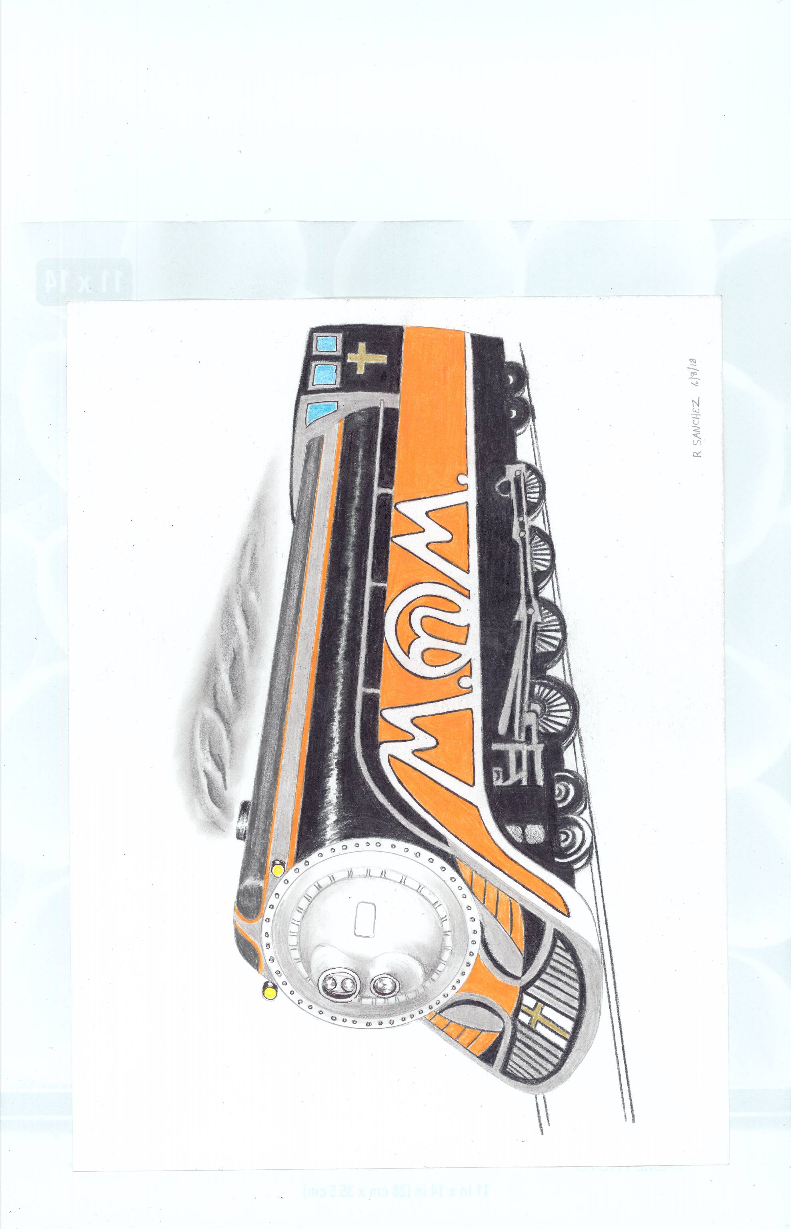
Artist = Richard Sanchez – 2nd Place
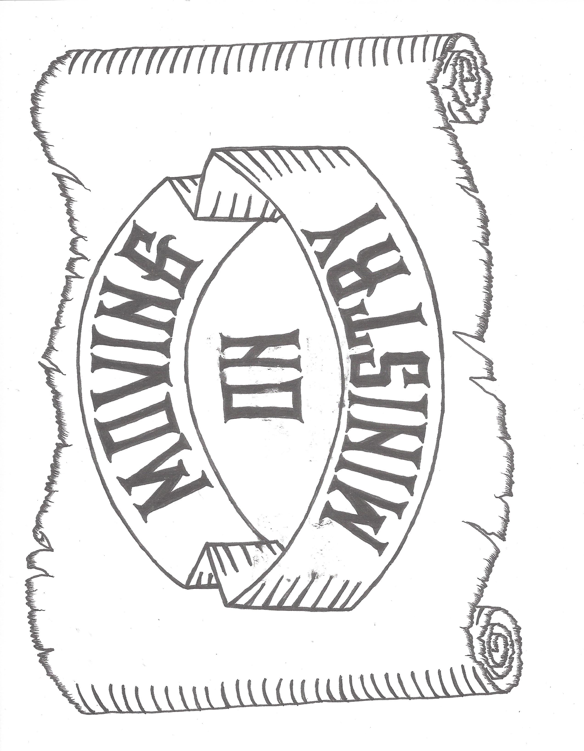
Artist – Jack W. Friend

************************************************************************

Update on Chaplain Bob’s Health

Bob & Linda have been active with “Bill Glass Behind the Walls Ministry” for the past 18 years. The last 2 years, Bob has been going in as one of the bikers with his 2005 Titan Sidewinder. In 2017 he did SATF Corcoran Prison on May 5, Soledad Prison on Sept. 23 and CRC Prison on Oct. 28, 2017. For 2018. Bob had to cancel Lancaster prison on March 10 and Santa Rita, CA area facilities on March 24 due to weather. Bob will also be participating in the Fresno, Kings and Tulare, CA area on May 4-5, 2018.

The Parkinson’s has become slightly more noticeable and the doctors are surprised how slowly it has gained any ground. (Could it be that your inmate’s prayers for Bob are being heard?) Bob can still predominately stop the shaking in the right hand (only affected area to date).

For the past couple months, Bob’s legs have been swollen and retaining fluid. Aug, 26th Bob finally went to the doctor after his wife, Linda, and mother, Jeanne, were trying to get him to see a doctor. The doctor had some lab tests run and some chest x-rays taken. He then explained that the common cause of the symptoms was congenital heart disease. The doctor scheduled Bob for Monday, August 28th for follow-up, The lab tests came back good – Praise The Lord. Bob was then referred to a cardiologist, where he had an EKG, PET Scan and ultrasound. Bob was scheduled for Sept 26th for follow-up results of these tests.

The results were no heart problems and in fact Bob had a very good heart.

I need to mention that Linda and I have received the BEST MEDICAL CARE I could ask for since we were able to get the military medical coverage since I was in the California Air National Guard for 21 years (Aircraft electrician) and California Army National Guard (Core of engineers and Military academy) for 2 years. Having worked in the medical field for over 20 years, I have seen good care and I have seen bad care. I have been in hospitals that I would not send my dog to. I have seen veterinary facilities that I would rather go to instead of some hospitals, currently we use the Navel Air Station, Lemoore Hospital as our primary provider. They are GREAT!!

A quick story of medical service. I had hernia surgery at NASL and took in a large cake for the Doctor and staff. The doctor asked me what it was for? I answered that is was for what he did for me. He replied “I only did what I was supposed to do.” I said “”most doctors don’t.” At a later date my wife, Linda, had a colonoscopy. I brought in another cake. The doctor asked what this cake was for. I replied that any man that was getting that close to my wife either deserved a drink or a cake. The doctor stated “I wish I had more husbands with your attitude.”

Letters Behind the Bars
************************************************************************
The following letter was sent to “Sister Denise” of Jesus Prayer Ministry. Bob and Linda have already run into facilities not allowing birthday cards, limiting letters to 2 pages, no colored paper or envelopes, banning contest mail and blocking reprints of articles.
Dear Denise,
Do our elected leaders care about families or not? I hear lots of politicians say they want to help former prisoners get back on their feet and lead productive lives. Some even say they understand how difficult prison is for the family members left behind.
But then we see announcements like the one made at the Coleman Federal Prison Complex in Florida. Prisoners there will no longer be able to order books from publishers or places like Amazon. Instead, they'll have to go through the prison to order the book — and then pay a 30 percent surcharge on top of the retail price. Children also will no longer be able to send birthday and holiday cards to their parents in prison.
Not to be outdone, the Florida State Department of Corrections announced plans to cut visiting time in half for families. Instead of being able to see their loved ones every weekend, family members will only be allowed to go every other weekend — and for a limited amount of time.
One FAMM member in Florida told us she goes to see her incarcerated son every weekend because he is all she has left. Do our leaders care about families or not? Do they even believe in rehabilitation at all?
I know prison administrators will say these new rules are needed to keep contraband, such as drugs, out of the prisons. But most prison officials admit that guards are more likely to smuggle in contraband than family members and friends. Also, even if the problem exists, is cutting off family contact and efforts to read and learn the only way to address this problem? Of course not.
If our leaders care about prisoners and their families, they will stop proposing and passing these petty and cruel rules. But we can't sit around and hope they see the light. We need to make them feel the heat. You can help right now by doing two simple things:
1. Tell your friends and families to join FAMM. There is no membership fee, no cost to get our emails and updates.
2. If you or someone you know has been in prison or is in prison today, please join our Facebook "FAMMilies in Action" page. There, affected families give and receive support to one another and learn of opportunities to support reform.
Kevin Ring President, FAMM

****************************************************

Letter to Isaac;
Thank you for sharing the story of me testifying for you to keep you off death row. The coordinator you shared it with started to share your story with all the Bill Glass volunteers and was saying that “Isaac said Chaplain Bob saved my life” and then he pointed at me and said “Chaplain Bob, would you like to tell the story?” I replied that I would try and gave the story through tears of my testifying to the jury to not put you (Isaac) on death row, but rather use your life to save others. The volunteers were moved by my tears and I asked them to pray for the overcoming of the LWOP.
What nobody knew about me was that on Wednesday, 5/2/18, at the Tollhouse retreat property, I had a tractor get out of my control and ran over my leg as it tore down my dome structure going up for the new pumphouse, pinned me against the structure and tried to run 4 wheel drive up my right leg. I felt my leg being crushed and then go limp. I got the diesel motor on the tractor stopped and started removing myself and broken timber from the tractor. I had some pain but shock hid it. I would not pull up my pant leg for fear of what I might see. I packed up and returned home. At home Linda looked at it (bruises, holes, swelling and scrapes) and said I needed to go to emergency. My mother also said to go to the hospital. I didn’t go.
The next day, Thursday 5/3/18, was training sessions and prison assignments in Fresno, CA. for Behind the Walls Ministry. I rode the motorcycle in to Fresno and back to Visalia (approx. 110 mi.). On Friday, 5/4/18, I was assigned to Corcoran State Prison and rode the motorcycle (Approx. 100 mi.) and spent the day on yard 3B. On Saturday, 5/5/18, I was assigned to Pleasant Valley State Prison in Coalinga with the motorcycle ride being approximately 140 miles. I spent the day on yards C & D. I noticed that standing for a long time caused great pain and swelling in the right foot and leg. Saturday night more of my friends insisted having it checked, so I agreed to go to emergency on Sunday morning.
Sunday morning Linda and I headed to Naval Air Station, Lemoore (NASL) hospital. We were a Sunday walk-in patient and seen by the doctor within 20 minutes (better than civilian facilities). The Doctor was concerned about the swelling, soreness down to the bone and possibilities of blood clots. We were sent to Kaweah Delta Medical Center (KDMC) Emergency in Visalia. They ran a doppler to check for blood clots and took many x-rays. Spent a little over 4 ½ hours in emergency, finally done. Then a lady medical technician came out and said “I have some good news and some bad news. The good news is no blood clots. The bad news is you fractured both the tibia and the fibula in your right leg.” She then continued to explain there was nothing to do since the bones were already healing in place. A lot of pain, but God promised no more than I can stand. I was then referred back to my primary care.
No x-rays were sent by KDMC, so NASL Hospital took new ones. The new x-rays showed there was compound fractures of both the tibia and the fibula back around 1980. NASL diagnosis was the following:
DIAGNOSIS: TECHNIQUE: ANKLE RIGHT (3 VIEWS)
COMPARISON: Right tib-fib radiographs from the same day.
FINDINGS: Old healed distal tibia and fibula diaphyseal fractures. No acute
fracture identified. There is moderate soft tissue swelling about the distal
lower extremity and ankle. Alignment is normal. The joint spaces are
preserved. No ankle joint effusion. Scattered vascular calcifications are
present.
IMPRESSION:
Old healed distal tibia and fibula diaphyseal fractures. No acute fracture
identified.
Moderate soft tissue swelling about the distal lower extremity and ankle.
DIAGNOSIS: TECHNIQUE: LEG RIGHT
COMPARISON: Right ankle radiographs from the same day.
FINDINGS: Old healed distal tibia and fibula diaphyseal fractures. No acute
fracture identified. There is moderate soft tissue swelling about the distal
lower extremity and ankle. Alignment is normal. The joint spaces are
preserved. Scattered vascular and dystrophic calcifications are present.
IMPRESSION:
Old healed distal tibia and fibula diaphyseal fractures. No acute fracture
identified.
Moderate soft tissue swelling about the distal lower extremity and ankle.

I did the same type thing of ignoring the pain and injury when I broke the left leg skydiving by being stupid with a high-speed landing. Ignoring does not make it go away. As we have also found, ignoring God does not make Him go away. Chaplain Bob
****************************************************************************************
Dear Chaplain Bob & Linda
In the last issue of your publication it indicated you were seeking a “logo.”

Along with these few lines you should find part of a manila folder upon which I have drawn one for consideration. It was kept to black and white since it is cheaper and far less likely to come out wrong when printed out./ it was alsp kept as simple as possible to avoid its coming out blurred or misprinted.

Should you choose to use it, please, instead of sending me any money order, send to me Bibles as listed according to importance, so that if you can’t order both, you can order the first one for me.

Order from 1-800=CHRISTIAN
1-900-247=4784
OR Christianbook.com

Catalog # UW484574 The NASB Ryrie Study Bible
Bonded leather black $ 46.99

Catalog # UW080374 The NKJV Unapologetic Study Bible
Bonded leather black $ 49.99

Trust you can well understand the importance of having different translations of God’s Word and of a study Bible. They would be worth their weight in gold to me and would be preferred to $ on my books.
Jack W, Friend

Npte; Eric has volunteered to take care of this, no matter what.

********************************************************************

Letters from the Bars (con’t)

************************************************************************
The Cross of Calvary
Dedicated to Beatriz

The cross of Calvary indeed set me free
Because prior to this the enemy had a hold on me,.
Again and again and again I fell to the Devil’s trickery
But Christ parted darkness with His awesome light.
And because of this I regained my sight.
The enemy still plots to recapture me with all of his might.
Today I am so Christ focused, I don’t pay the Devil no mind
He and everything associated with him is so lost and far behind.
Today all I scream is VICTORY, VICTORY, VICTORY, VICTORY,
For what my Lord and /savior Jesus Christ did
On that cross of Calvary - - - Thank you Jesus I honor and praise you because you are worthy Runako Ayers

************************************************************************
Listing of our staff and volunteers;

Chaplain Bob K - - - - - - - - - - CEO
Sister Linda K- - - - - - - - - - - - Volunteer / Letters
George C..- - - - - - - - - - - - - - - Co-Chair
Eric S.- - - - - - - - - - - - - - - - - - Treasure
Sister Irie - - - - - - - - - - - - - - - - Secretary
Bonnie - - - - - - - - - - - - - - - - - - Volunteer
Ramona C - - - - - - - - - - - - - - - - Volunteer
Beatriz - - - - - - - - - - - - - - - - - - - Outreach
************************************************************************
M.O.M. Ministry “Do’s and Don’ts”

What we don’t do:

Send money to you or family
Trade personal information
Contact people for you
Look up information on people
Spend time doing research for you
Set you up with individuals for romance
M.O.M. is NOT a dating service
We Do NOT do legal work
Will not give our phone numbers
Will not accept collect phone calls
Might not send pictures

************************************************************************
What we will do:

Chapel service at prison facilities
Ministry program for churches
Transitional Planning class
Send newsletters with S.A.S.E. ($.49)

Send 56 page resources S.A.S.E ($.91)

Contact Heather Layne about concert
Take it to the Yard event
Platform speakers
Motorcycles
Concerts
Magicians

Print testimonies & artwork.

************************************************************************

For those wishing to get a mailed copy of current newsletters, please send donation (if able), stamps or S.A.S.E. and request the current newsletter. The newsletters (all 97 volumes) as well as the 56 page “Resources From M.O.M.” list are available on the web site.

www.MovingOnMinistry.com

You can have a loved one or someone with internet access print the newsletters or Resources and mail them to you, or send a 6” X 9” S.A.S.E. with $ .91 postage and any donation for printing of Resources.

************************************************************************

Suggested donations for printouts.

Newsletters $1.00

Resources List $3.00 (or 6 stamps)

** Please distribute this information to your visitors and inmate loved ones. **

********************************************************************************************PLEASE also send us the names of your Warden, Chaplain and Inmate Services Program Directors. We need these to confirm and schedule events.

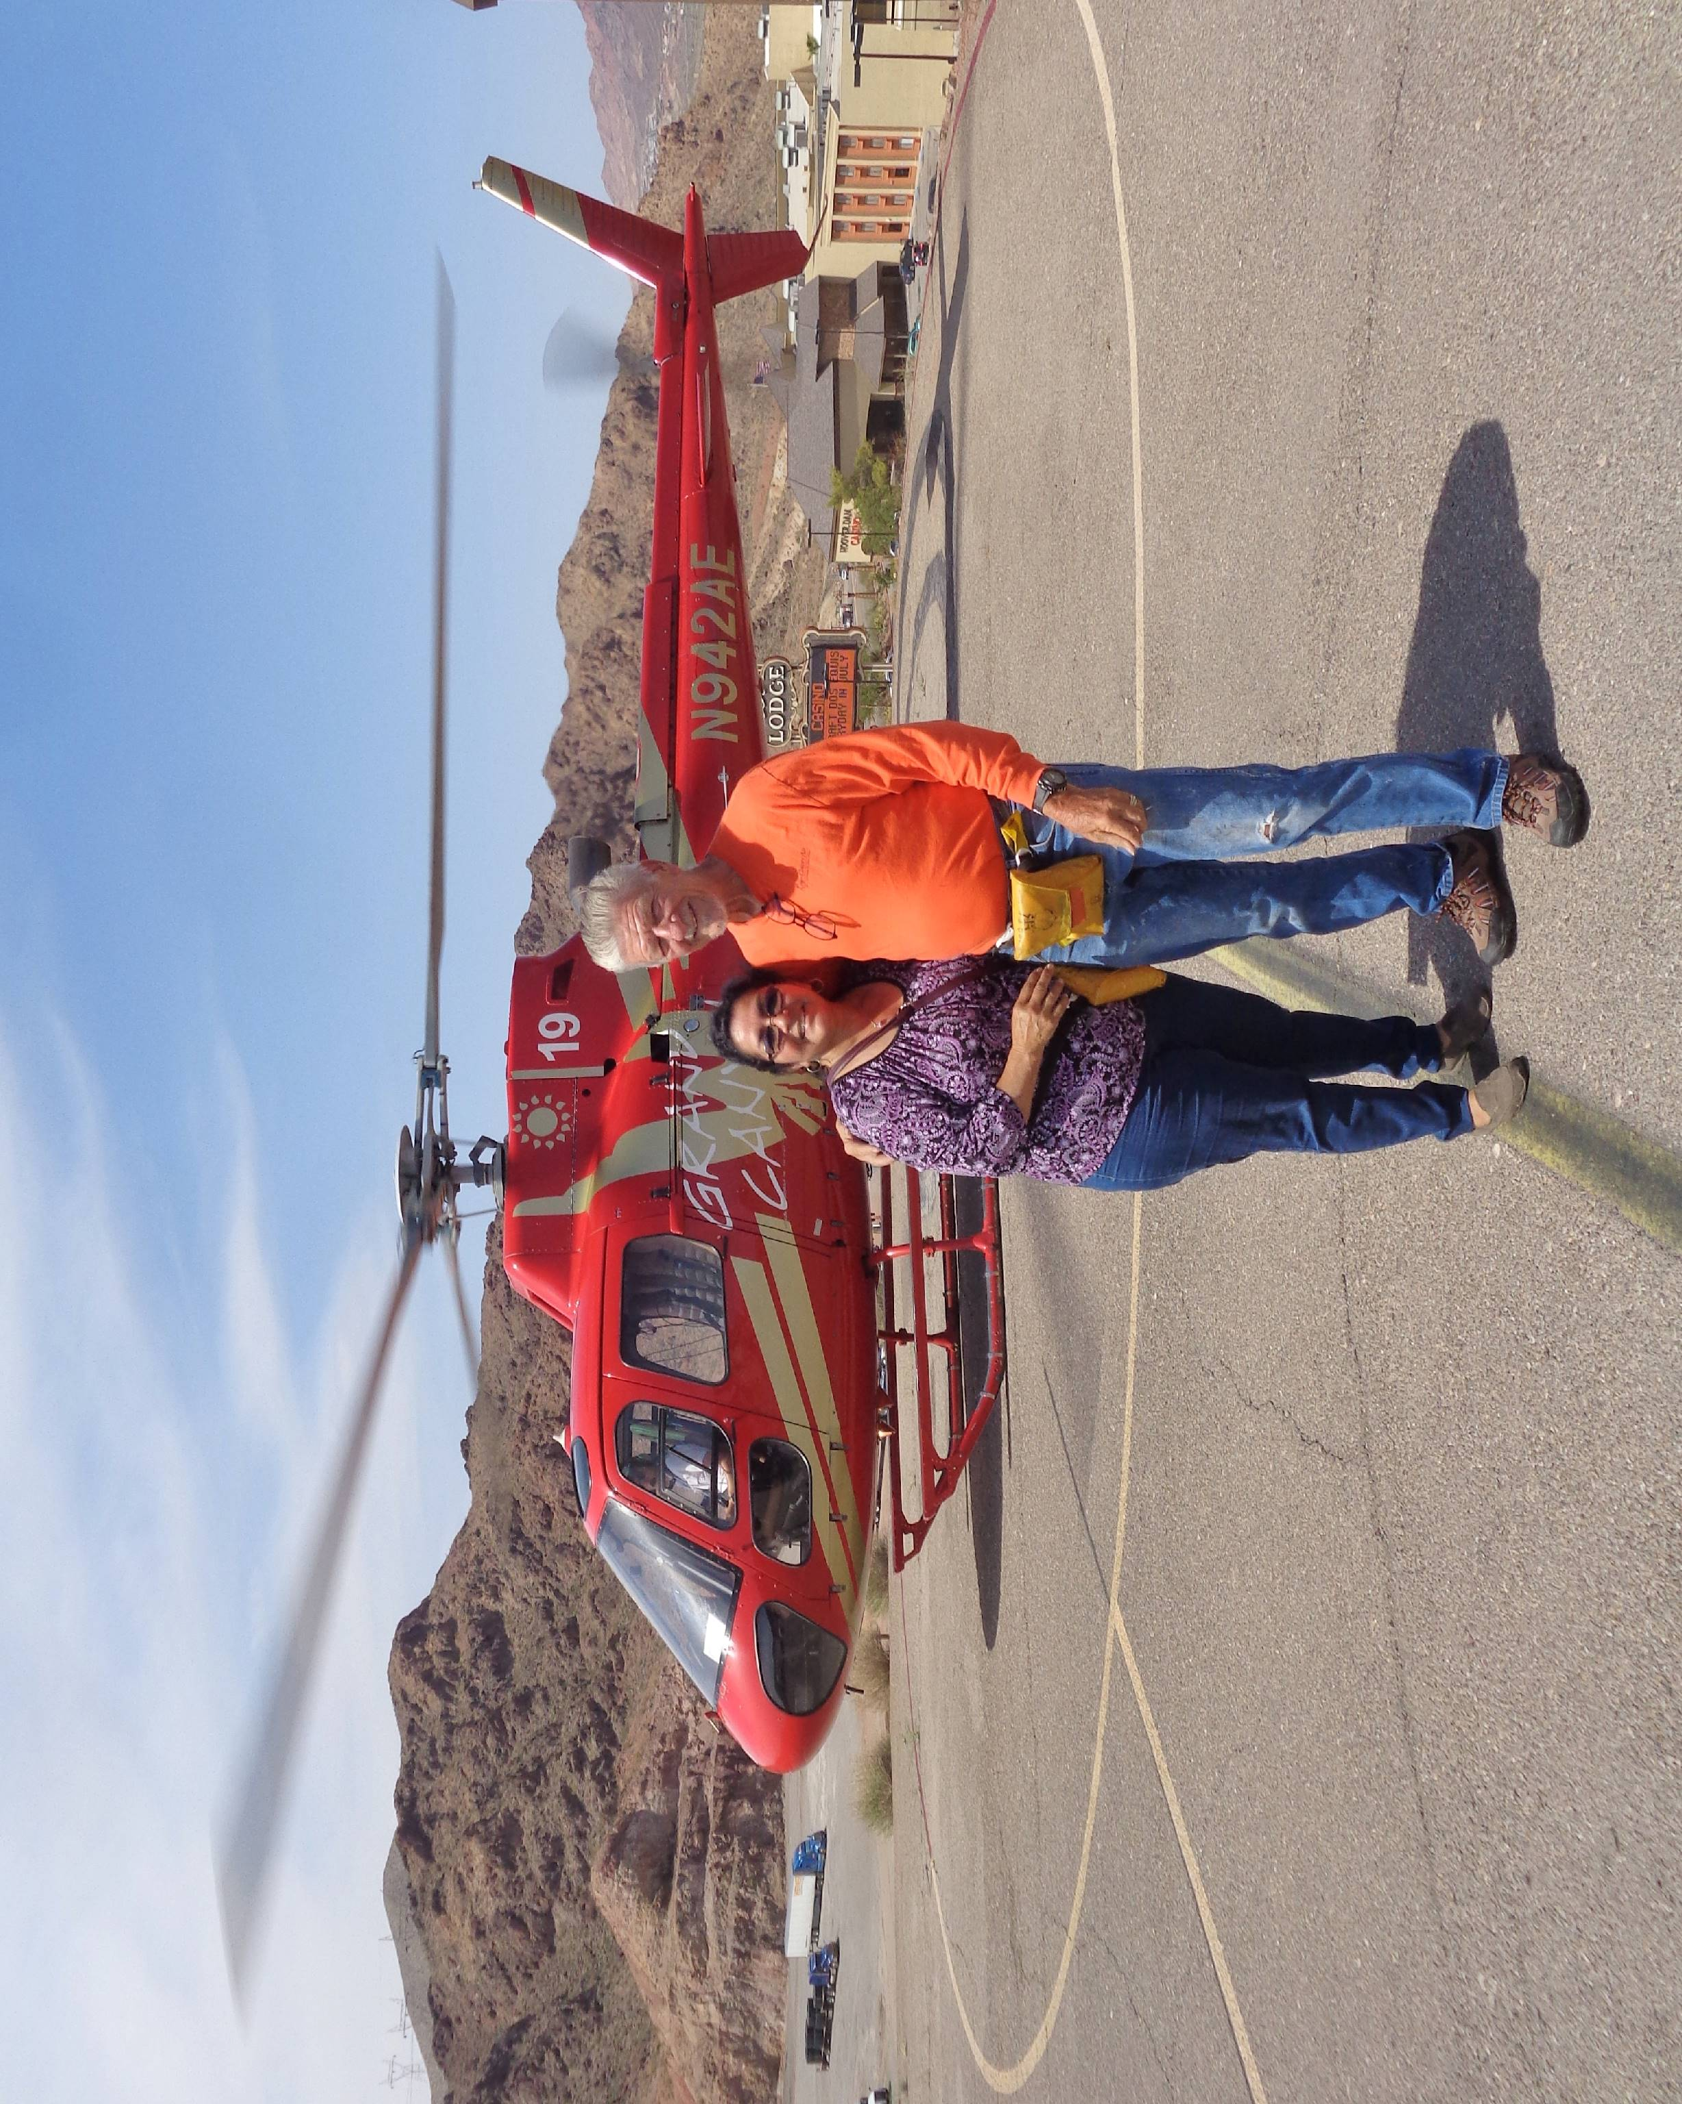
Bob & Linda had their first helicopter ride with a tour of Lake Mead, Hoover Dam, Colorado River and Black canyon

Bridge and Hoover Dam as viewed from helicopter


